Study Measures

Table of Contents
1 Cognitive Measures 3
1.1 N-Back task 3
1.2 Simple Span 3
1.3 Symmetry Span Task 3
1.4 Figure Exchange Task 3
1.5 AXCPT Task 3
1.6 Raven’s Progressive Matrices 3
1.7 Letter Compare 3
1.8 Choice Reaction Time 3
1.9 Letter/Number Series 4
1.10 Synonyms 4
1.11 Counter Task 4
1.12 Inductive Reasoning 4
1.13 Relational monitoring 4
1.14 Task switching 5
1.15 Change detection 5
1.16 Latin Square 5
1.17 Spatial Relation Task 6
1.18 Stroop 7
1.19 Anti Sacade 7
1.20 Complex Span 8
1.21 Flanker Task 8
1.22 Perceptual Discrimination 9
1.23 Categorisation 9
1.24 Multiplication Test 10
1.25 Rating task 10
1.26 Contingency Learning Task 11
1.27 Ultimatum Task 13
1.28 Dictator Game 13
1.29 Learning and Assessment Task 13
1.30 Emotional Labelling Task 13
1.31 Analogies 13
2 Non-cognitive Measures 14
2.1 Demographic Questionnaire 14
2.2 Implicit Theories Of Personality 16
2.3 Implicit Theories Of Intelligence 16
2.4 Need For Cognition 16
2.5 Goal Orientation 17
2.6 Memory And Reasoning Self Concept 18
2.7 Big Five Personality 18
2.8 Self-efficacy scale 20
2.9 General Self-efficacy scale 20
2.10 Cognitive Failures Questionnaire 21
2.11 Cognitive Reflection 22
2.12 Emotional Intelligence 22
2.13 Narcissism Scale 23
2.14 -The Situational Test of Emotional Understanding 25
2.15 Situational Test of Emotion Management-Brief (STEM-B) 27
2.16 Japanese and Caucasian Brief Affect Recognition Test 31
2.17 Trait Emotional Intelligence Questionnaire 32
2.18 Wong-Law Emotional Intelligence Scale 33
2.19 Psychological Wellbeing 33
2.20 Positive and Negative Affect (Self-report) 35
2.21 Social Media Questionnaire 35
2.22 Mobile phone questionnaire 35
2.23 SOCIAL NETWORK SCALE 35
2.24 Sociability Scale 36
2.25 37
2.26 Self-Rated Emotional Intelligence Scale 37
2.27 The Profile of Emotional Competence 37
2.28 Metacognitive Monitoring Scale 39
2.29 Toronto Alexithymia Scale 39
2.30 Perth Alexithymia Questionnaire 39
2.31 Social Axioms Survey II (SAS II) 40
2.32 Academic Self-Concept Scale (ASCS) 41

Cognitive Measures

N-Back task
In the N-Back task, a series of stimuli are presented, and the task is to indicate whether the current stimulus matches the one from n steps earlier. This requires constantly updating the working memory buffer to keep track of which earlier stimulus is to be compared with the current one.

Simple Span
In the span task, participants are presented a series of letters or digits presented one at a time (at a rate of two letters/digits per second). Once a recall screen appears, participants have to recall the most recent n
number of items (e.g., the last six letters) in serial order. Before each trial, subjects were told the number of letters/digits (set size) that they should remember, but they are not told how many letters/digits would be presented in a series. The set size ranges from 3 to 9. Subjects completed two trials per set size for a total of 14 trials.

Symmetry Span Task
Participants recall sequences of red square locations within a matrix against a background symmetry-judgment task. In the symmetry-judgment task, an 8 x 8 grid displaying a symmetrical or non-symmetrical pattern is displayed. The participant must respond to whether the pattern is symmetrical, followed by a 4 x 4 matrix with a filled red square. The participant must remember the sequence of red square locations in set sizes ranging from 2-5 symmetry-memory matrices.

Figure Exchange Task
This task requires participants to mentally reorder a sequence of four symbols, where only adjacent symbols can be exchanged. The participant must indicate the number of adjacent figure exchanges required to transform one symbol sequence to a second symbol sequence.

AXCPT Task
Participants are presented with a sequence of letters on a screen, one at a time. Participants are instructed to make a positive response to a target cue, when preceded by a probe letter, and a negative response to a non-target cue/probe sequence.

Raven’s Progressive Matrices
A 38-item abstract reasoning task used to assess fluid intelligence that involves participants completing a series of patterns by selecting the appropriate missing pattern.

Letter Compare
Subjects decide whether sets of three, six, or nine consonants/numbers on either side of a line were the same or different. If the sets were the same, subjects clicked SAME; if sets differed, subjects clicked DIFFERENT. Subjects had 30 s to complete as many comparisons as possible, with the total correct across four 30-s administrations used as the dependent variable.

Choice Reaction Time
The Choice Reaction Time Task is a measure of processing speed. Each trial involves the presentation of two basic stimuli of the same type (e.g., lines, circles). The participants are instructed to respond according to a predetermined rule (e.g., “select the longest line”, “select the green circle”).

Participants respond by pressing one of two keys representing each choice (“A” and “L”).
Types of stimuli include lines and shapes. Choices include length, width, and colour. Each block consists of the same type and choice throughout that block. Each block consists of approximately 40 trials, allowing the participants to take a break between trials.

Letter/Number Series
7 items present a series of numbers,/Letters and subjects identify the response option that continues the sequence. The number of is used as the dependent variable. For example:

Synonyms
In an 18-item multiple choice style test, participants read a word and then select and appropriate synonym from a list of 5 options which include distractors, antonyms and randomly selected words. Participants are given 4 minutes to complete as many as possible

Counter Task
Participants are presented with a series of inter-mixed large and small squares. They must simultaneously keep counts of the small and large circles. After a presentation sequence of around 25 seconds participants report the number of small and large squares they believe occurred in the sequence.

Inductive Reasoning
In an 18-item multiple choice style test, participants read a logical statement and then select from a list of 5 possibilities which statement can be inferred from the statement without any additional information. Participants are given 4 minutes to complete as many as possible.

Relational monitoring
The Relation Monitoring Task is a measure of relational binding. A continuous sequence of symbol patterns are presented. Each trial displays a 3 x 3 array of strings (letters, numbers, or pictures of common objects). Each array has only one type of stimuli, as demonstrated below.

The participants' task is to monitor the array and respond (press spacebar) if they notice a predefined pattern within a single row or column. For instance, in the condition same, the participants are asked to detect whether three strings ending with the same letter/digit are located within a single row or column. In the condition ascending, the task is to look for three strings within a row or column ending in digits that consecutively ascend (e.g., 3-4-5). The rules all relate the strings in some way (same, different, ascending).
In the figural version, the only rule is to look for a categorical match amongst the objects, whereby all objects within an entire row or column belong to the same category. The categories of objects in the figural version are listed in the Appendix A.
If the array matches the pattern, the participant are instructed to respond to these trials in order to be scored as correct. Participants are instructed to only respond to trials that match the rule, so responses given to no-relation trials are recorded as false alarm errors. Each trial lasts between 3-5.5 seconds, though responding to a trial ends the current trial immediately.
Each block constitutes a single match rule using a single stimulus type. Brief instructions explain the type of stimulus and match rule before each block. Each block consists of approximately 40 trials, of which half conform to the rule. Each block is preceded by 5 practice trials demonstrating the rule. The blocks are presented in random order.

Task switching
Task switching requires processes that are not necessary when simply repeating the same task and generally incurs costs in the form of increased response latency and errors. Tasks switching tasks will require participants to shift their response/stimuli pairings, essentially having people doing two tasks in rapid alternation. For example, participants need to respond to number and letter combinations. E.g. responding whether a number is odd vs even on some trials vs saying if it is higher or lower than 7 on alternate trials

Change detection
Change Detection Tasks are measures of attention and visuospatial memory. Participants are presented with an array of stimuli (dots, crosses, or simple objects; left). After 2-7 seconds, the array disappears. After a blank inter-stimulus interval of 2-5 seconds, the array returns, with (right) or without changes. The participant’s task is to decide whether the current array is the same or different from the previous array.

Participants respond by pressing the key corresponding to their choice (“A” or “L”).
The number of stimuli and the nature of their grouping (number of clusters and number of stimuli per cluster) is randomly determined for each trial. In some trials, the instructions are to only focus on changes occurring in certain areas of the screen (e.g., “ignore any changes that occur on the right side of the screen”).
In some the trials, the simple stimuli (dots/crosses) are replaced with complex stimuli (e.g., shells, fish, or crabs) on a contextual background (e.g., water). In some of these trials, the instructions are to only focus on changes occurring to certain objects (e.g., just the shells) and ignore other objects (e.g., fish).

Latin Square
The Latin Square Task is a measure of working memory and abstract reasoning. Participants are presented with incomplete 4 x 4 Latin squares with the task to find which shape (circle, triangle, square, or cross) should fit the marked (?) target cell.
Participants respond by clicking on one of the response options below the array.

Spatial Relation Task
The Spatial-Relation Task is a measure of relational reasoning. Participants are instructed to read a set of premises that relate a set of objects (labelled as ‘A’ through ‘E’) by spatial locations. The task is to deduce the spatial relation between two target objects given the premises.
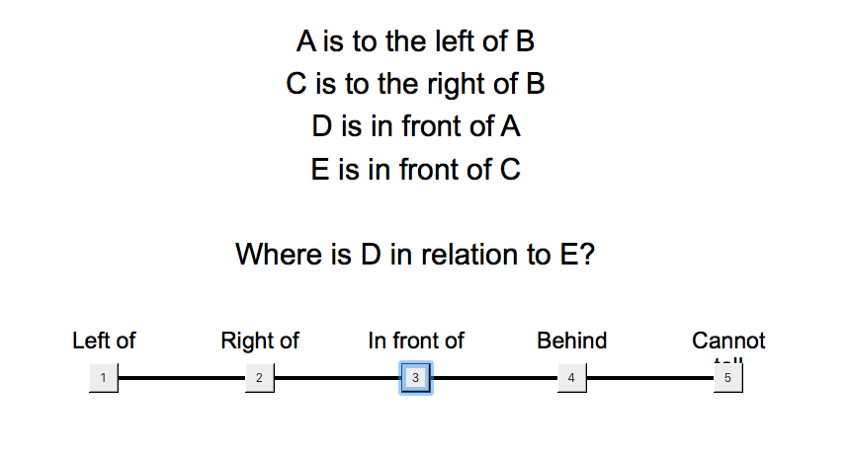

Stroop
The Stroop Task is a measure of inhibition and attentional control. Participants are presented with words sequentially and instructed to respond with the colour the word is printed in. The colour responses correspond to letters on the key (e.g., RED = ‘Z’). The words themselves are names of colours: green, blue, red, orange.


Anti Sacade
The Anti-saccade Task is a measure of inhibition and attentional control that can be measured directly with eye tracking or indirectly with keyboard presses. Participants are instructed to fixate on a stimulus (a circle) in the centre of the screen. After a varying period of time, the stimulus moves to the left or right side of the screen. In the control trials, the participants must either not move their gaze (i.e., remain fixated on the centre) or follow the stimulus. In the experimental trials, the participant must move their gaze to the opposite side of the screen from the stimulus. In the behavioural version of the task, participants instead respond with keys corresponding to left or right (e.g., ‘A’ and ‘L’).
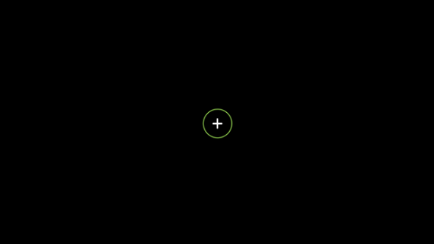

Complex Span
The Complex Span Task is a measure of working memory. Each trial involves the presentation of several (2-7) sequentially presented stimuli (digits; left). After each stimulus, the participant must also verify the truth of a simple arithmetic operation (right). Once all the stimuli have been presented, along with their alternating arithmetic operations, the participant is asked to recall the stimuli in correct serial order, by entering each digit with the keyboard
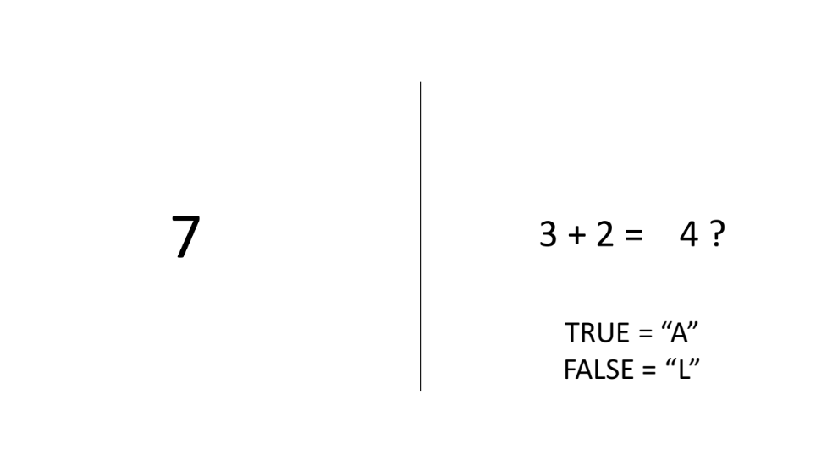

Flanker Task
The flanker task is a set of response inhibition tests used to assess the ability to suppress responses that are inappropriate in a particular context. The target is flanked by non-target stimuli which correspond either to the same directional response as the target (congruent flankers), to the opposite response (incongruent flankers), or to neither (neutralflankers). Participants respond based on the congruence of the target with context, Flanker items call for the opposite response of the target and are represented by different symbols
For example:
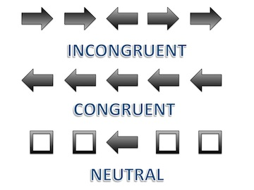

Perceptual Discrimination
Perceptual discrimination tasks require participants to make some king of perceptual decision about a stimulus (e.g. colour, motion, size etc.), usually in a very quick fashion. For example in a motion discrimination task, human subjects decide whether two sequentially presented motion stimuli move in the same or different directions



Categorisation
The general categorisation paradigm involves a category learning task adapted from Little & McDaniel (2015), where participants learn to categorise 12 stimuli (figure left) into one of two categories. Stimuli are composed of two coloured shapes, one inside of the other. Category membership is determined by the following rule: if the inner and outer shape matches in form/shape or colour they are members of one category (e.g., ‘blickets’) and if they do not match in either form or colour, they are the other category (e.g., ‘daxes). Participants can categorise the stimuli either by learning the rule or alternatively, given the limited number of stimuli, simply memorising the category to which a stimuli belongs based on its perceptual features. The paradigm is run in two phases, a training phase where participants categorise each of the 12 items multiple times, are prompted to provide metacognitive self- evaluations, and receive feedback as well as a subsequent test phase where participants are tested on i) the same items they saw previously, ii) unambiguous (previously unseen) transfer items that would be classified as one category using the rule and the same category using perceptual features, and iii) ambiguous (previously unseen) transfer items that would be classified as one category using the rule and the other category if using perceptual features (figure below).

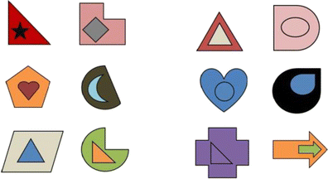

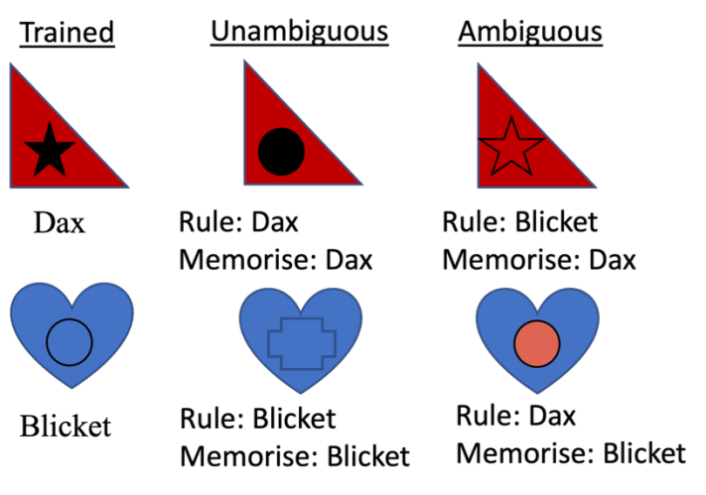

Multiplication Test
Participants will be presented with a series of multiplication questions consisting of one number multiplied by another number (e.g. 27 x 83). Participants will then be shown an answer that is correct and one that is incorrect yet plausible and prompted to choose the correct answer.

Rating task
In this task participants rate either/both the (1) age and (2) pleasantness of: faces, houses, and paintings. Faces have a neutral facial expression. Faces, houses and paintings were gathered from the Internet and online psych-psychics stimulus databases. They were chosen to cover a large variety of styles, such that different aesthetic tastes could be expressed, for example in terms of modern versus older periods as far back as the Middle Ages.

Example trial:

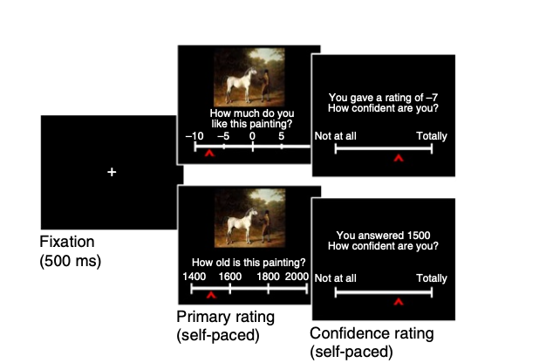

Contingency Learning Task
In this task, participants are told to learn the contingency between a cue and an outcome. Their goal is to determine if there is a causal relationship between the two events, that is, if the cue causes the outcome to occur. On each trial of the training phase, participants are shown whether the cue is present or absent, and asked to make a prediction about the target outcome by clicking on a horizontal slider. They are then provided feedback about whether the target outcome occurred or did not occur. At the end of the training phase, participants are asked to make a judgement about the causal relationship between the cue and the outcome.

For example, participants are told they are a scientist and need to work out if a new drug is effective.

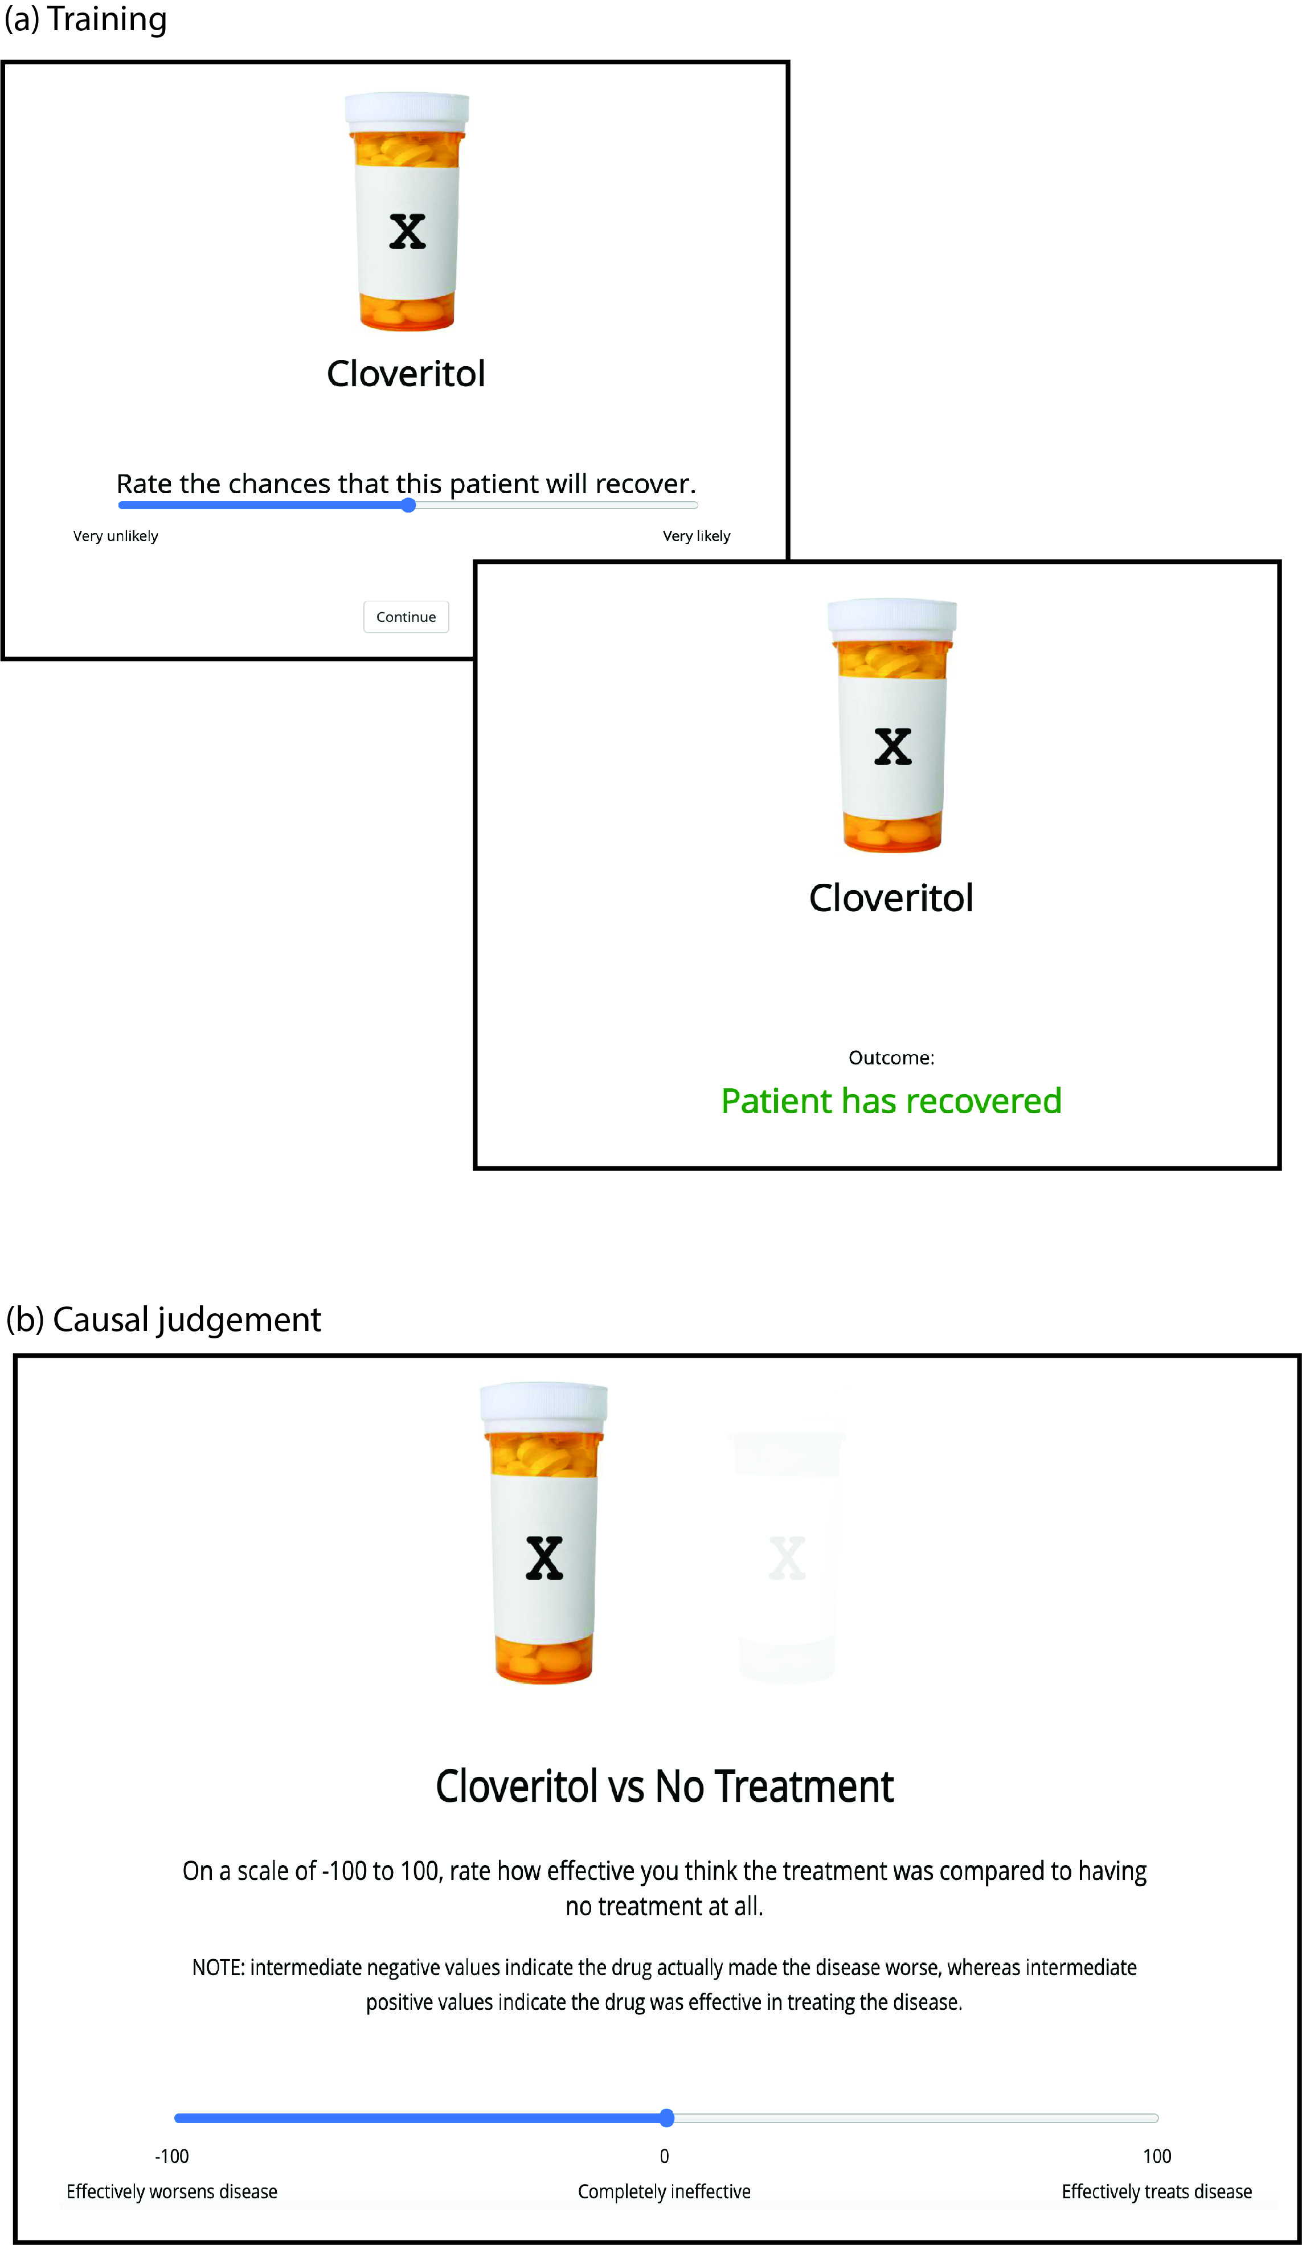

Ultimatum Task
In the task, one player (the proposer) is given a sum of money and must offer a portion of it to a second player (the responder). The responder can either accept or reject the offer. If the responder accepts, both players receive the proposed amounts. If the responder rejects, neither player receives anything. Although economic rationality suggests accepting any nonzero offer, people often reject unfair offers, highlighting the role of fairness, emotion, and social judgment in decision-making. The actual payment each participant receives in the same (as per the approved ethics protocol)

Dictator Game
In this task, one player (the dictator) is given a sum of money and must decide how much, if any, to give to a second player (the recipient), who has no power to reject the offer. Whatever amount the dictator chooses is final. Unlike the Ultimatum Game, the Dictator Game removes the strategic element, making it a purer measure of generosity and social preferences. Again, the actual payment each participant receives in the same (as per the approved ethics protocol)

Learning and Assessment Task
In this task, participants engage with educational content (e.g. psychology textbook passages) through one of different learning conditions (e.g., textbook-style passages or curated informational content). After the learning phase, all participants complete a standardised assessment that measures comprehension, retention, and application of the material. This design allows for comparisons of learning outcomes across different modes of content engagement

Emotional Labelling Task
Participants view emotionally evocative stimuli (e.g., facial expressions, brief video clips, or hypothetical scenarios) and select the emotion label that best represents their affective response from provided options (e.g., “happy,” “sad,” “angry,” “neutral”). Reaction times, label choices, and confidence ratings are recorded so that we can determine various decision-making metrics associated with affective reactivity. Stimuli are drawn from various standardised sets of stimuli: International Affective Picture System (IAPS; Lang Et al. 2008), Geneva Affective Picture Database (GAPED; Dan-Glauser et al., 2011), Open Affective Standardized Image Set (OASIS, Kurdi et al. 2017), Nencki Affective Picture System (NAPS Marchewka et al., 2014)

Analogies
Participants complete an online word-analogy task where item lists cue words in a fixed format—e.g., “a _ _ _ _ _, riddle, guess, think”—where one word is partially masked by underscores. Working left-to-right, participants type the hidden “correct response” that meaningfully relates the cues (here, “answer”). Items sample everyday vocabulary (objects, actions, relationships) and vary in difficulty to produce a broad performance range.

Non-cognitive Measures

Demographic Questionnaire

Instructions
The following information helps us to understand how individual differences in experiences and background influences learning.
- Year of Birth
  - _______
- Gender
  - Male
  - Female
  - Non-binary/Gender diverse
  - Prefer not to say
- Which country do you currently reside in?
- Is English your first language
  - Yes
  - No
    - What language do you speak at home:
      - _____________
    - How long have you been speaking English
      - < 1 year
      - 2-5 years
      - 5-10 years
      - + 10 years
    - How confident are you with your English skills
      - 0 = need assistance when out
      - 100 = proficient and confident
- Your highest level of schooling
  - Primary school
  - Secondary
  - Certificate/Diploma
  - Bachelors degree
  - Masters degree
  - PhD
- Parent 1 - highest level of schooling
  - Primary school
  - Secondary
  - Certificate/Diploma
  - Bachelors degree
  - Masters degree
  - PhD
- Parent 2 - highest level of schooling
  - Primary school
  - Secondary
  - Certificate/Diploma
  - Bachelors degree
  - Masters degree
  - PhD
- Employment
  - Retired (1)
  - Not in paid employment (2)
  - Casual (3)
  - Part-time (4)
  - Full-time (5)
- What is your usual yearly HOUSEHOLD income before tax, from all sources? (please include benefits, pensions, superannuation, etc.)
  - <30K
  - 30-60K
  - 60-90K
  - 90-120K
  - > 120K
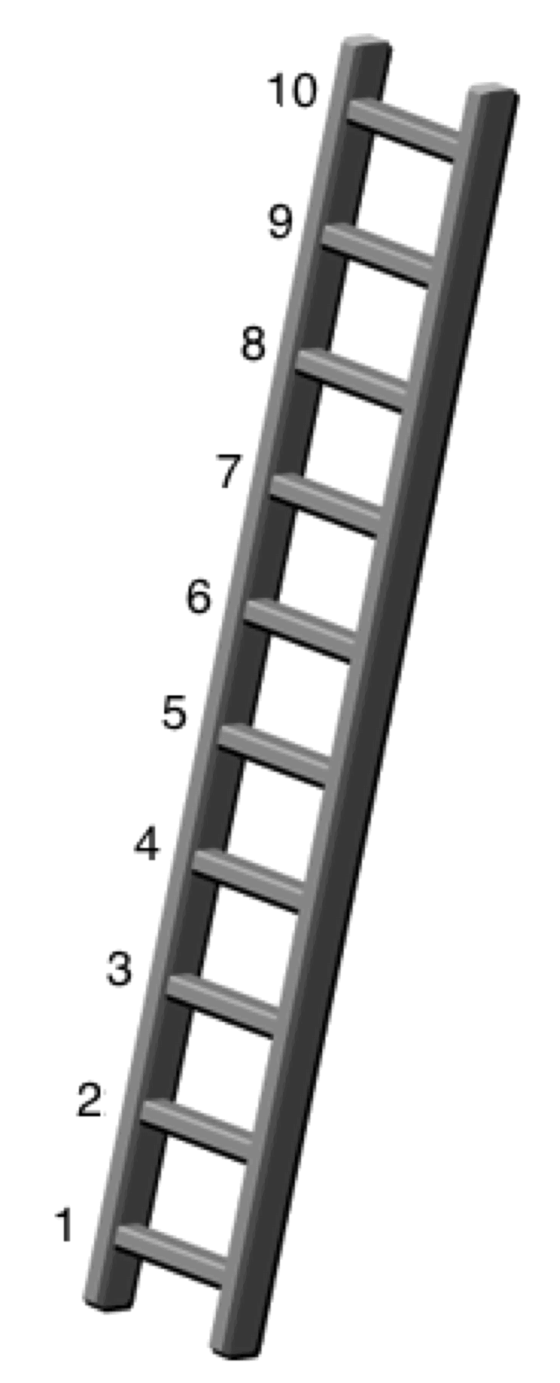
- Think of this ladder as representing where people stand in society. At the top of the ladder are the people who are best off – those who have the most money, most education and the best jobs. At the bottom are the people who are worst off – who have the least money, least education and the worst jobs or no job. The higher up you are on this ladder, the closer you are to people at the very top and the lower you are, the closer you are to the bottom. Where would you put yourself on the ladder?
Please select the number of the rung where you think you stand.
Response options: 1, 2, 3, 4, 5, 6, 7, 8, 9, 10

- Geographic location where you live
  - Urban
  - Suburban
  - Rural
- Rate how often you use the following resources to access information
  - Local library (0=never to 100 = daily)
  - University library (0=never to 100 = daily)
  - Newspapers (0=never to 100 = daily)
  - Internet (online) (0=never to 100 = daily)
  - Friends and family (0=never to 100 = daily)

Implicit Theories Of Personality
Scale
1-100 slider: Strongly Agree to Strongly disagree

Instructions
The following statements deal with your ideas about personality. There are no right or wrong answers. We are interested in your ideas. Read each statement. Using the scale below each statement, please indicate the extent to which you agree or disagree with each statement.

Items
- The kind of person you are, is something very basic about you and it can't be changed very much.
- You can do things differently, but the important parts of who you are can't really be changed.
- You can always substantially change the kind of person you are.
- You can change even your most basic qualities.

Implicit Theories Of Intelligence
Scale
1-100 slider: Strongly Agree to Strongly disagree

Instructions
The following statements deal with your ideas about intelligence. There are no right or wrong answers. We are interested in your ideas. Read each statement. Using the scale below each statement, please indicate the extent to which you agree or disagree with each statement.

Items
- You have a certain amount of intelligence, and you can't really do much to change it.
- No matter who you are, you can significantly change your intelligence level.
- You can learn new things, but you can't really change your basic intelligence.
- No matter how much intelligence you have, you can always change it quite a bit.

Need For Cognition
Scale
1-100 slider: Strongly Agree to Strongly disagree

Instructions
The following statements deal with your preferences in thinking. There are no right or wrong answers. We are interested in your ideas. Read each statement. Using the scale below each statement, please indicate the extent to which you agree or disagree with each statement.
Items
- I would prefer complex to simple problems.
- I like to have responsibility of handling a situation that requires a lot of thinking.
- Thinking is not my idea of fun.
- I would rather do something that requires little thought than something that is sure to challenge my thinking abilities.
- I try to anticipate and avoid situations where there is likely chance I will have to think in depth about something.
- I find satisfaction in deliberating hard and for long hours.
- I only think as hard as I have to.
- I prefer to think about small, daily projects to long-term ones.
- I like tasks that require little thought once I've learned them.
- The idea of relying on thought to make my way to the top appeals to me.
- I really enjoy a task that involves coming up with new solutions to problems.
- Learning new ways to think doesn't excite me very much.
- I prefer my life to be filled with puzzles that I must solve.
- The notion of thinking abstractly is appealing to me.
- I would prefer a task that is intellectual, difficult, and important to one that is somewhat important but does not require much thought.
- I feel relief rather than satisfaction after completing a task that required a lot of mental effort
- It's enough for me that something gets the job done; I don't care how or why it works.
- I usually end up deliberating about issues even when they do not affect me personally.

Goal Orientation
Scal
1-100 slider: Strongly Agree to Strongly disagree

Instructions
The following statements deal with your ideas about goals people pursue at work. There are no right or wrong answers. We are interested in your ideas. Read each statement. Using the scale below each statement, please indicate the extent to which you agree or disagree with each statement.
Items
- I often read materials related to my work to improve my ability.
- I would rather prove my ability on a task that I can do well at than to try a new task.
- I would avoid taking on a new task if there was a chance that I would appear rather incompetent to others.
- I am willing to select a challenging work assignment that I can learn a lot from.
- I am concerned with showing that I can perform better than my co-workers.
- Avoiding a show of low ability is more important to me than learning a new skill
- I often look for opportunities to develop new skills and knowledge.
- I try to figure out what it takes to prove my ability to others at work.
- I am concerned about taking on a task at work if my performance would reveal that I had low ability.
- I enjoy challenging and difficult tasks at work where I'll learn new skills.
- I enjoy it when others at work are aware of how well I am doing.
- I prefer to avoid situations at work where I might perform poorly.
- For me, development of my work ability is important enough to take risks.
- I prefer to work on projects where I can prove my ability to others.
- When I don't understand something at work, I prefer to avoid asking what might appear to others to be "dumb questions" that I should know the answer to already.
- I prefer to work in situations that require a high level of ability and talent

Memory And Reasoning Self Concept
Scale
1-100 slider: Strongly Agree to Strongly disagree

Instructions
In this questionnaire you will be presented with a series of statements which ask you to describe your own abilities, preferences and strategies with respect to reasoning and memory. To respond to the questionnaire, read each statement CAREFULLY and then use the sliding scale below each item to indicate how accurately that statement describes you. The scale ranges from 'Extremely Inaccurate' to 'Extremely Accurate'. Use the values in between to indicate that the statement applies to you to varying degrees.

This is NOT a test - THERE ARE NO 'RIGHT' OR 'WRONG' ANSWERS.
We are interested in how you see yourself. Describe yourself AS YOU ARE NOW - NOT as you think you should be, or how you would like to be in the future. Describe yourself as you GENERALLY or TYPICALLY are.

Try to respond as accurately and honestly as possible. Proceed at your own pace, but DO NOT spend too much time thinking about any one item. The first response that comes to mind is typically the best.

Items
1. My memory is above average. (M)
2. To solve a problem, I rely on reasoning abilities.
3. Compared to other intellectual abilities (i.e., attention, reasoning) my memory is good. (M)
4. I enjoy being involved in activities that require reasoning of some sort.
5. I can remember more material than the average person. (M)
6. I feel confident when solving problems that require reasoning skills.
7. I'm satisfied with my memory. (M)
8. In an exam situation, I get answers right mostly by reasoning.
9. I describe myself as a person with reasoning abilities that are above average.
10. I rely on my memory to get me through exams. (M)
11. I am happy with my reasoning abilities.
12. I enjoy engaging in activities that require me to remember things. (M)
13. I can reason better than the average person.
14. For exam purposes, I memorize material easily. (M)
15. Compared to my other cognitive abilities, my reasoning is sound.
16. I have a good memory. (M)

Big Five Personality
Scale
1-100 slider: Strongly Agree to Strongly disagree

Instructions
You will now be presented with phrases describing people's behaviours. Please use the rating scale next to each phrase to describe how accurately each statement describes you. Describe yourself as you generally are now, not as you wish to be in the future. Describe yourself as you honestly see yourself, in relation to other people you know of the same sex as you are, and roughly your same age. So that you can describe yourself in an honest manner your responses will be kept in absolute confidence. Please read each statement carefully, and then indicate the accuracy of the statement.

Items
- Often feel blue.
- Feel comfortable around people.
- Believe in the importance of art.
- Have a good word for everyone.
- Am always prepared.
- Dislike myself.
- Make friends easily.
- Have a vivid imagination.
- Believe that others have good intentions.
- Pay attention to details.
- Am often down in the dumps.
- Am skilled in handling social situations.
- Tend to vote for progressive political candidates.
- Respect others.
- Get chores done right away.
- Have frequent mood swings.
- Am the life of the party.
- Carry the conversation to a higher level.
- Accept people as they are.
- Carry out my plans.
- Panic easily.
- Know how to captivate people.
- Enjoy hearing new ideas.
- Make people feel at ease.
- Make plans and stick to them.
- Rarely get irritated.
- Have little to say.
- Am not interested in abstract ideas.
- Have a sharp tongue.
- Waste my time.
- Seldom feel blue.
- Keep in the background.
- Do not like art.
- Cut others to pieces.
- Find it difficult to get down to work.
- Feel comfortable with myself.
- Would describe my experiences as somewhat dull.
- Avoid philosophical discussions.
- Suspect hidden motives in others.
- Do just enough work to get by.
- Am not easily bothered by things.
- Don't like to draw attention to myself.
- Do not enjoy going to art museums.
- Get back at others.
- Don't see things through.
- Am very pleased with myself.
- Don't talk a lot.
- Tend to vote for conservative political candidates.
- Insult people.
- Shirk my duties.

Self-efficacy scale
Scale
1-100 slider: Extremely confident to Not confident at all

Instructions
The following questions ask about your perceptions of your ability to perform various activities, such as concentrating, multi-tasking, remembering facts, information and everyday cognitive tasks. If you were given a test of your ability to perform each activity, please indicate how confident you are about your ability to perform each of the following activities.

Items
- Watch an interesting movie or read an interesting book.
- Listen to a boring but important lecture.
- Listen to a conversation when there is something else you want to do.
- Listen to a conversation with several people in which the topic is constantly changing.
- Shift your attention back and forth between two activities.
- Stay focused on an activity when you are being distracted by a second activity.
- Finish reading a newspaper article when something more interesting catches your eye.
- Remember names and facts after reading an article about a familiar topic.
- Remember names and facts after reading an article about an unfamiliar topic.
- Remember mobile phone numbers after hearing them just once.
- Remember the names of people you meet briefly for the first time at a party.
- Complete moderately difficult cognitive games and puzzles.

General Self-efficacy scale
Scale
1-100 slider: Strongly Agree to Strongly disagree

- I can always manage to solve difficult problems if I try hard enough.
- If someone opposes me, I can find the means and ways to get what I want.
- It is easy for me to stick to may aims and accomplish my goals.
- I am confident that I could deal efficiently with unexpected events.
- Thanks to my resourcefulness, I know how to handle unforeseen situations.
- I can solve most problems if I invest the necessary effort.
- I can remain calm when facing difficulties because I can rely on my coping abilities.
- When I am confronted with a problem. I can usually find several solutions.
- If I am in trouble, I can usually think of a solution.
- I can usually handle whatever comes my way.

Cognitive Failures Questionnaire
Scale: 7-point scale -
Very
often
Quite often
Occasionally
Very
rarely
Never
The following questions are about minor mistakes which everyone makes from time to time, but some of which happen more often than others. We want to know how often these things have happened to you in the past 6 months. Please circle the appropriate number.

- Do you read something and find you haven’t been thinking about it and must read it again?
- Do you find you forget why you went from one part of the house to the other?
- Do you fail to notice signposts on the road?
- Do you find you confuse right and left when giving directions?
- Do you bump into people?
- Do you find you forget whether you’ve turned off a light or a fire or locked the door?
- Do you fail to listen to people’s names when you are meeting them?
- Do you say something and realize afterwards that it might be taken as insulting?
- Do you fail to hear people speaking to you when you are doing something else?
- Do you lose your temper and regret it?
- Do you leave important letters unanswered for days?
- Do you find you forget which way to turn on a road you know well but rarely use?
- Do you fail to see what you want in a supermarket (although it’s there)?
- Do you find yourself suddenly wondering whether you’ve used a word correctly?
- Do you have trouble making up your mind?
- Do you find you forget appointments?
- Do you forget where you put something like a newspaper or a book?
- Do you find you accidentally throw away the thing you want and keep what you meant to throw away – as in the example of throwing away the matchbox and putting the used match in your pocket?
- Do you daydream when you ought to be listening to something?
- Do you find you forget people’s names?
- Do you start doing one thing at home and get distracted into doing something else (unintentionally)?
- Do you find you can’t quite remember something although it’s “on the tip of your tongue”?
- Do you find you forget what you came to the shops to buy?
- Do you drop things?
- Do you find you can’t think of anything to say?

Cognitive Reflection
*Free response

- A bat and a ball cost $1.10 in total. The bat costs $1.00 more than the ball. How much does the ball cost?
- If it takes 5 machines 5 minutes to make 5 widgets, how long would it take 100 machines to make 100 widgets?
- In a lake, there is a patch of lily pads. Every day, the patch doubles in size. If it takes 48 days for the patch to cover the entire lake, how long would it take for the patch to cover half of the lake?

Emotional Intelligence

The Mayer-Salovey-Caruso Emotional Intelligence Test (MSCEIT)
Mayer, J. D., Salovey, P., Caruso, D. R., & Sitarenios, G. (2003). Measuring Emotional Intelligence With the MSCEIT V2.0. Emotion, 3, 97-105.

The test takes 35-40 minutes to complete and consists of 141 items. There are four types of items, representing: (1) Identifying emotions; (2) Using emotions; (3) Understanding emotions; and (4) Managing emotions. An example item of each type is provided below.
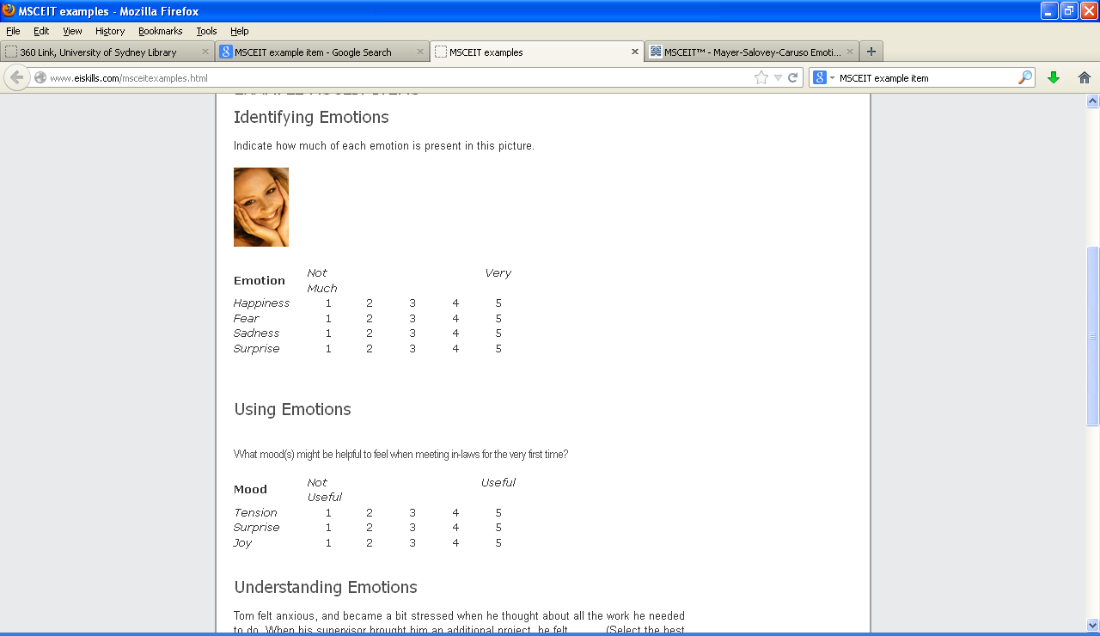

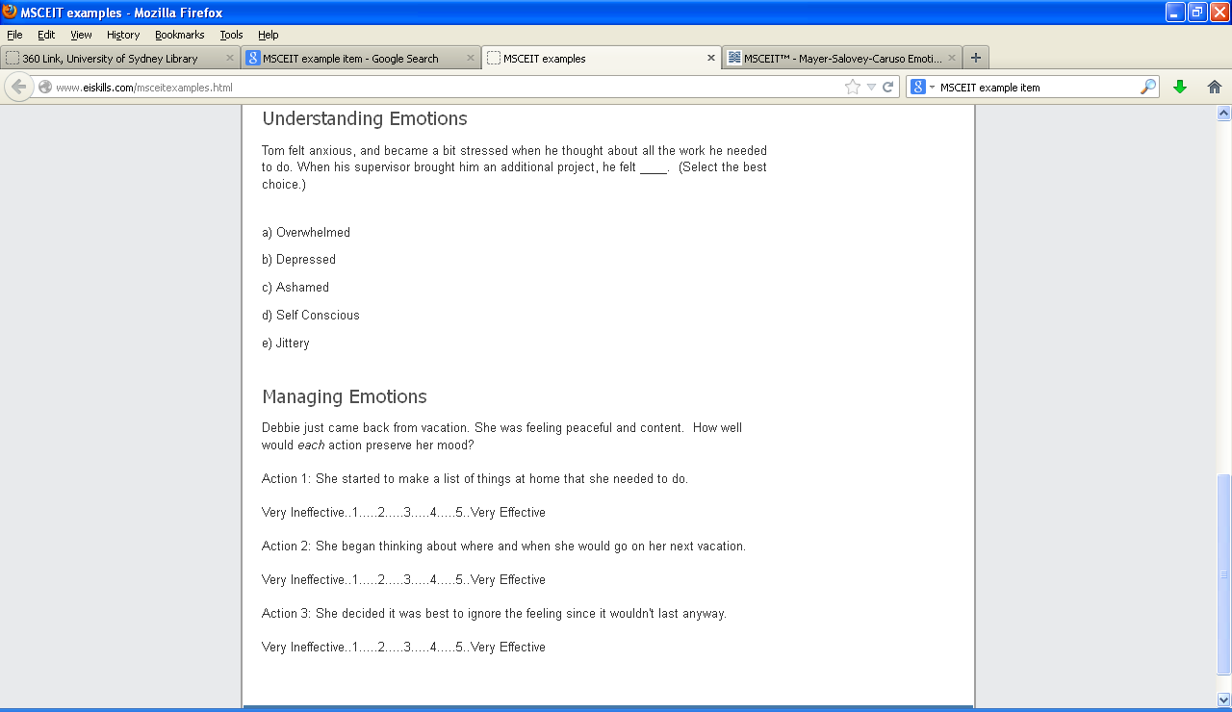

Narcissism Scale
Scale
1-100 slider: Strongly Agree to Strongly disagree

Grandiosity
Exploitativeness
4. I can usually talk my way out of anything.
10. I can make anyone believe anything I want them to.
15. I find it easy to manipulate people.
23. I can read people like a book.
Self-Sacrificing Self-Enhancement
22. I feel important when others rely on me.
25. Sacrificing for others makes me the better person.
33. I like to have friends who rely on me because it makes me feel important.
39. I try to show what a good person I am through my sacrifices.
Grandiose Fantasy
26. I often fantasize about accomplishing things that are probably beyond my means.
31. I often fantasize about being rewarded for my efforts.
42. I often fantasize about performing heroic deeds.
45. I often fantasize about being recognized for my accomplishments.
Vulnerability
Contingent Self-Esteem
8. When people don’t notice me, I start to feel bad about myself.
30. It’s hard to feel good about myself unless I know other people admire me.
32. I am preoccupied with thoughts and concerns that most people are not interested in me.
36. It’s hard for me to feel good about myself unless I know other people like me.
Hiding the Self
9. I often hide my needs for fear that others will see me as needy and desperate.
28. It’s hard to show others the weaknesses I feel inside.
46. I can’t stand relying on other people because it makes me feel weak.
50. When others get a glimpse of my needs, I feel anxious and ashamed.
Devaluing
17. Sometimes I avoid people because I’m concerned that they’ll disappoint me.
21. When others don’t meet my expectations, I often feel ashamed about what I wanted.
27. Sometimes I avoid people because I’m afraid they won’t do what I want them to do.
34. Sometimes I avoid people because I’m concerned they won’t acknowledge what I do for them.
Entitlement Rage
12. I get annoyed by people who are not interested in what I say or do.
18. I typically get very angry when I’m unable to get what I want from others.
37. It irritates me when people don’t notice how good a person I am.
38. I will never be satisfied until I get all that I deserve.

-The Situational Test of Emotional Understanding
The following questions each describe a situation, and ask you to choose which of five emotions is most likely to result from that situation.

Here is an example:
Clara receives a gift. Clara is most likely to feel?
(a) happy (b) angry (c) frightened (d) bored (e) hungry

If you think Clara would feel happy, you would select option A and then move to the next question. There are 19 questions.

1. Xavier completes a difficult task on time and under budget. Xavier is most likely to feel?
(a) Surprise (b) Pride (c) Relief (d) Hope (e) Joy

2. If the current situation continues, Denise's employer will probably be able to move her job to a location much closer to her home, which she really wants. Denise is most likely to feel?
(a) Distress (b) Joy (c) Surprise (d) Hope (e) Fear

3. Song finds out that a friend of hers has borrowed money from others to pay urgent bills, but has in fact used the money for less serious purposes. Song is most likely to feel?
(a) Anger (b) Excitement (c) Contempt (d) Shame (e) Horror

4. Charles is meeting a friend to see a movie. The friend is very late and they are not in time to make it to the movie. Charles is most likely to feel?
(a) Depressed (b) Frustrated (c) Angry (d) Contemptuous (e) Distressed

5. Someone believes that another person harmed them on purpose. There is not a lot that can be done to make things better. The person involved is most likely to feel?
(a) Dislike (b) Rage (c) Jealousy (d) Surprise (e) Anxiety

6. Jim enjoys spending Saturdays playing with his children in the park. This year they have sporting activities on Saturdays and cannot go to the park with him any more. Jim is most likely to feel?
(a) Angry (b) Sad (c) Frustrated (d) Distressed (e) Ashamed

7. Megan is looking to buy a house. Something happened and she felt regret. What is most likely to have happened?
(a) She didn't make an offer on a house she wanted, and now she is trying to find out if it is too late.
(b) She found a house she liked that she didn't think she would find.
(c) She couldn't make an offer on a house she liked because the bank didn't get her the money in time.
(d) She didn't make an offer on a house she liked and now someone else has bought it.
(e) She made an offer on a house and is waiting to see if it is accepted.

8. Mary was working at her desk. Something happened that caused her to feel surprised. What is most likely to have happened?
(a) Her work-mate told a silly joke.
(b) She was working on a new task she hadn't dealt with before.
(c) She found some results that were different from what she thought they would be.
(d) She realized she would not be able to complete her work.
(e) She had to do a task she didn't normally do at work.

9. Someone thinks that another person has deliberately caused something good to happen to them. They are most likely to feel?
(a) Hope (b) Pride (c) Gratitude (d) Surprise (e) Relief

10. By their own actions, a person reaches a goal they wanted to reach. The person is most likely to feel?
(a) Joy (b) Hope (c) Relief (d) Pride (e) Surprise

11. An unwanted situation becomes less likely or stops altogether. The person involved is most likely to feel?
(a) Regret (b) Hope (c) Joy (d) Sadness (e) Relief

12. Hasad tries to use his new mobile phone. He has always been able to work out how to use different appliances, but he cannot get the phone to function. Hasad is most likely to feel?
(a) Distressed (b) Confused (c) Surprised (d) Relieved (e) Frustrated

13. Dorian's friend is ill and coughs all over him without bothering to turn away or cover his mouth. Dorian is most likely to feel?
(a) Anxiety (b) Dislike (c) Surprise (d) Jealousy (e) Rage

14. Quan and his wife are talking about what happened to them that day. Something happened that caused Quan to feel surprised. What is most likely to have happened?
(a) His wife talked a lot, which did not usually happen.
(b) His wife talked about things that were different to what they usually discussed.
(c) His wife told him that she might have some bad news.
(d) His wife told Quan some news that was not what he thought it would be.
(e) His wife told a funny story.

15. A supervisor who is unpleasant to work for leaves Alfonso's work. Alfonso is most likely to feel?
(a) Joy (b) Hope (c) Regret (d) Relief (e) Sadness

16. The nature of Sara's job changes due to unpredictable factors and she no longer gets to do the portions of her work that she most enjoyed. Sara is most likely to feel?
(a) Ashamed (b) Sad (c) Angry (d) Distressed (e) Frustrated

17. Leila has been unable to sleep well lately and there are no changes in her life that might indicate why. Leila is most likely to feel?
(a) Angry (b) Scared (c) Sad (d) Distressed (e) Guilty

18. Someone believes another person has deliberately caused something good to stop happening to them. However, they feel they can do something about it. They are most likely to feel?
(a) Angry (b) Contemptuous (c) Distress (d) Depressed (e) Frustrated

19. Matthew has been at his current job for six months. Something happened that caused him to feel regret. What is most likely to have happened?
(a) He did not apply for a position he wanted and has found out that someone else less qualified got the job.
(b) He did not apply for a position he wanted and has started looking for a similar position.
(c) He found out that opportunities for promotion have dried up.
(d) He found out that he didn't get a position he thought he would get.
(e) He didn't hear about a position he could have applied for and now it is too late.

Situational Test of Emotion Management-Brief (STEM-B)
In this test, you will be presented with a few brief details about an emotional situation, and asked to choose from four responses the most effective course of action to manage both the emotions the person is feeling and the problems they face in that situation.

Although more than one course of action might be acceptable, you are asked to choose what you think the most effective response for that person in that situation would be.

Remember, you are not necessarily choosing what you would do, or the nicest thing to do, but choosing the most effective response for that situation.

1. Wai-Hin and Connie have shared an office for years but Wai-Hin gets a new job and Connie loses contact with her. What action would be the most effective for Connie?
(a) Just accept that she is gone and the friendship is over.
(b) Ring Wai-Hin and ask her out for lunch or coffee to catch up.
(c) Contact Wai-Hin and arrange to catch up but also make friends with her replacement.
(d) Spend time getting to know the other people in the office, and strike up new friendships.

2. Manual is only a few years from retirement when he finds out his position will no longer exist, although he will still have a job with a less prestigious role. What action would be the most effective for Manual?
(a) Carefully consider his options and discuss it with his family.
(b) Talk to his boss or the management about it.
(c) Accept the situation, but still feel bitter about it.
(d) Walk out of that job.

3. Surbhi starts a new job where he doesn’t know anyone and finds that no one is particularly friendly. What action would be the most effective for Surbhi?
(a) Have fun with his friends outside of work hours.
(b) Concentrate on doing his work well at the new job.
(c) Make an effort to talk to people and be friendly himself.
(d) Leave the job and find one with a better environment.

4. Andre moves away from the city his friends and family are in. He finds his friends make less effort to keep in contact than he thought they would. What action would be the most effective for Andre?
(a) Try to adjust to life in the new city by joining clubs and activities there.
(b) He should make the effort to contact them, but also try to meet people in his new city.
(c) Let go of his old friends, who have shown themselves to be unreliable.
(d) Tell his friends he is disappointed in them for not contacting him.

5. Clayton has been overseas for a long time and returns to visit his family. So much has changed that Clayton feels left out. What action would be the most effective for Clayton?
(a) Nothing – it will sort itself out soon enough.
(b) Tell his family he feels left out.
(c) Spend time listening and getting involved again.
(d) Reflect that relationships can change with time.

6. Daniel has been accepted for a prestigious position in a different country from his family, who he is close to. He and his wife decide it is worth relocating. What action would be the most effective for Daniel?
(a) Realize he shouldn’t have applied for the job if he didn’t want to leave.
(b) Set up a system for staying in touch, like weekly phone calls or emails.
(c) Think about the great opportunities this change offers.
(d) Don’t take the position.

7. Mei Ling answers the phone and hears that close relatives are in hospital critically ill. What action would be the most effective for Mei Ling?
(a) Let herself cry and express emotion for as long as she feels like.
(b) Speak to other family to calm herself and find out what is happening, then visit the hospital.
(c) There is nothing she can do.
(d) Visit the hospital and ask staff about their condition.

8. Shona has not spoken to her nephew for months, whereas when he was younger they were very close. She rings him but he can only talk for five minutes. What action would be the most effective for Shona?
(a) Realize that he is growing up and might not want to spend so much time with his family any more.
(b) Make plans to drop by and visit him in person and have a good chat.
(c) Understand that relationships change, but keep calling him from time to time.
(d) Be upset about it, but realize there is nothing she can do.

9. Mina and her sister-in-law normally get along quite well, and the sister-in-law regularly baby-sits for her for a small fee. Lately she has also been cleaning away cobwebs, commenting on the mess, which Mina finds insulting. What action would be the most effective for Mina?
(a) Tell her sister-in-law these comments upset her.
(b) Get a new babysitter.
(c) Be grateful her house is being cleaned for free.
(d) Tell her only to baby-sit, not to clean.

10. Juno is fairly sure his company is going down and his job is under threat. It is a large company and nothing official has been said. What action would be the most effective for Juno?
(a) Find out what is happening and discuss his concerns with his family.
(b) Try to keep the company afloat by working harder.
(c) Start applying for other jobs.
(d) Think of these events as an opportunity for a new start.

11. Mallory moves from a small company to a very large one, where there is little personal contact, which she misses. What action would be the most effective for Mallory?
(a) Talk to her workmates, try to create social contacts and make friends.
(b) Start looking for a new job so she can leave that environment.
(c) Just give it time, and things will be okay.
(d) Concentrate on her outside-work friends and colleagues from previous jobs.

12. A demanding client takes up a lot of Jill’s time and then asks to speak to Jill’s boss about her performance. Although Jill’s boss assures her that her performance is fine, Jill feels upset. What action would be the most effective for Jill?
(a) Talk to her friends or workmates about it.
(b) Ignore the incident and move on to her next task.
(c) Calm down by taking deep breaths or going for a short walk.
(d) Think that she has been successful in the past and this client being difficult is not her fault.

13. Blair and Flynn usually go to a cafe after the working week and chat about what’s going on in the company. After Blair’s job is moved to a different section in the company, he stops coming to the cafe. Flynn misses these Friday talks. What action would be the most effective for Flynn?
(a) Go to the cafe or socialize with other workers.
(b) Don’t worry about it, ignore the changes and let Blair be.
(c) Not talk to Blair again.
(d) Invite Blair again, maybe rescheduling for another time.

14. Michelle’s friend Dara is moving overseas to live with her partner. They have been good friends for many years and Dara is unlikely to come back. What action would be the most effective for Michelle?
(a) Forget about Dara.
(b) Spend time with other friends, keeping herself busy.
(c) Think that Dara and her partner will return soon.
(d) Make sure she keeps in contact through email, phone or letter writing.

15. Hannah’s access to essential resources has been delayed and her work is way behind schedule. Her progress report makes no mention of the lack of resources. What action would be the most effective for Hannah?
(a) Explain the lack of resources to her boss or to management.
(b) Learn that she should plan ahead for next time.
(c) Document the lack of resources in her progress report.
(d) Don’t worry about it.

16. Reece’s friend points out that her young children seem to be developing more quickly than Reece's. Reece sees that this is true. What action would be the most effective for Reece?
(a) Talk the issue over with another friend.
(b) Angrily confront her friend about making such statements.
(c) Realize that children develop at different rates.
(d) Talk to a doctor about what the normal rates of development are.

17. Jumah has been working at a new job part-time while he studies. His shift times for the week are changed at the last minute, without consulting him. What action would be the most effective for Jumah?
(a) Refuse to work the new shifts.
(b) Find out if there is some reasonable explanation for the shift changes.
(c) Tell the manager in charge of shifts that he is not happy about it.
(d) Grumpily accept the changes and do the shifts.

18. Julie hasn’t seen Ka for ages and looks forward to their weekend trip away. However, Ka has changed a lot and Julie finds that she is no longer an interesting companion. What action would be the most effective for Julie?
(a) Cancel the trip and go home.
(b) Realize that it is time to give up the friendship and move on.
(c) Understand that people change, so move on, but remember the good times.
(d) Concentrate on her other, more rewarding friendships.

Japanese and Caucasian Brief Affect Recognition Test

Please view the video.

(Examples items only; test cannot be uploaded due to formatting issues)


1.

Which emotion is being displayed?
(a) Happiness (b) Contempt (c) Disgust (d) Sadness (e) Anger (f) Surprise (g) Fear


2.

Which emotion is being displayed?
(a) Happiness (b) Contempt (c) Disgust (d) Sadness (e) Anger (f) Surprise (g) Fear

Trait Emotional Intelligence Questionnaire
Please answer each statement below by putting a circle around the number that best reflects your degree of agreement or disagreement with that statement. Do not think too long about the exact meaning of the statements. Work quickly and try to answer as accurately as possible. There are no right or wrong answers.
Completely Disagree |  |  |  |  |  | Completely Agree
1 | 2 | 3 | 4 | 5 | 6 | 7

- Expressing my emotions with words is not a problem for me.
- I often find it difficult to see things from another person’s viewpoint.
- On the whole, I’m a highly motivated person.
- I usually find it difficult to regulate my emotions.
- I generally don’t find life enjoyable.
- I can deal effectively with people.
- I tend to change my mind frequently.
- Many times, I can’t figure out what emotion I'm feeling.
- I feel that I have a number of good qualities.
- I often find it difficult to stand up for my rights.
- I’m usually able to influence the way other people feel.
- On the whole, I have a gloomy perspective on most things.
- Those close to me often complain that I don’t treat them right.
- I often find it difficult to adjust my life according to the circumstances.
- On the whole, I’m able to deal with stress.
- I often find it difficult to show my affection to those close to me.
- I’m normally able to “get into someone’s shoes” and experience their emotions.
- I normally find it difficult to keep myself motivated.
- I’m usually able to find ways to control my emotions when I want to.
- On the whole, I’m pleased with my life.
- I would describe myself as a good negotiator.
- I tend to get involved in things I later wish I could get out of.
- I often pause and think about my feelings.
- I believe I’m full of personal strengths.
- I tend to “back down” even if I know I’m right.
- I don’t seem to have any power at all over other people’s feelings.
- I generally believe that things will work out fine in my life.
- I find it difficult to bond well even with those close to me.
- Generally, I’m able to adapt to new environments.
- Others admire me for being relaxed.

Wong-Law Emotional Intelligence Scale
Indicate the extent to which you agree or disagree to each of the statements.
Strongly Disagree | Disagree | Neither Agree nor Disagree | Agree | Strongly Agree
1 | 2 | 3 | 4 | 5

- I have a good sense of why I feel certain feelings most of the time.
- I have a good understanding of my own emotions.
- I really understand what I feel.
- I always know whether I am happy or not.
- I always know my friends’ emotions from their behaviour.
- I am a good observer of others’ emotions.
- I am sensitive to the feelings and emotions of others.
- I have a good understanding of the emotions of people around me.
- I always set goals for myself and then try my best to achieve them.
- I always tell myself I am a competent person.
- I am a self-motivating person.
- I would always encourage myself to try my best.
- I am able to control my temper so that I can handle difficulties rationally.
- I am quite capable of controlling my own emotions.
- I can always calm down quickly when I am very angry.
- I have good control of my emotions

Psychological Wellbeing
Instructions: Circle one response below each statement to indicate how much you agree or disagree.

Strongly agree | Somewhat agree | Agree a little | Neither agree nor disagree | Disagree a little | Somewhat disagree | Strongly disagree
1 | 2 | 3 | 4 | 5 | 6 | 7

1. I like most parts of my personality.
2. When I look at the story of my life, I am pleased with how things have turned out so far.
3. Some people wander aimlessly through life, but I am not one of them.
4. The demands of everyday life often get me down.
5. In many ways I feel disappointed about my achievements in life.
6. Maintaining close relationships has been difficult and frustrating for me.
7. I live life one day at a time and don't really think about the future.
8. In general, I feel I am in charge of the situation in which I live.
9. I am good at managing the responsibilities of daily life.
10. I sometimes feel as if I've done all there is to do in life.
11. For me, life has been a continuous process of learning, changing, and growth.
12. I think it is important to have new experiences that challenge how I think about myself and the world.
13. People would describe me as a giving person, willing to share my time with others.
14. I gave up trying to make big improvements or changes in my life a long time ago
15. I tend to be influenced by people with strong opinions
16. I have not experienced many warm and trusting relationships with others.
17. I have confidence in my own opinions, even if they are different from the way most other people think.
18. I judge myself by what I think is important, not by the values of what others think is important.

Positive and Negative Affect (Self-report)
Please indicate the extent you felt this way over the LAST DAY/WEEK/MONTH.
Rate how much you felt each emotion from 1 (very slightly or not at all) to 5 (extremely).

- Determined
- Attentive
- Alert
- Inspired
- Active
- Afraid
- Nervous
- Upset
- Ashamed
- Hostile
- Calm
- Content
- Peaceful
- Relaxed

Social Media Questionnaire

- I spend a lot of time thinking about social media apps or planning my use of social media apps
- I feel the need to use social media apps more and more
- I use social media apps so I can forget about my problems
- I’ve tried to use my social media apps less but I can’t
- I’ve become stressed or upset if I am not allowed to use my social media apps
- I use social media apps so much that it has had a bad effect on my schoolwork or job

Mobile phone questionnaire
- I interrupt whatever else I am doing when I am contacted on my phone
- I often use my phone for no particular reason
- I feel connected to others when I am using my phone
- Arguments have arisen with others because of my phone use
- I lose track of how much I am using my phone
- I often think about my phone when I am not using it
- I have been unable to reduce my phone use
- The thought of being without my phone makes me feel distressed

SOCIAL NETWORK SCALE

FAMILY: Considering the people to whom you are related by birth, marriage, adoption, etc…

1. How many relatives do you see or hear from at least once a month?
0 = none 1 = one 2 = two 3 = three or four 4 = five thru eight 5 = nine or more

2. How often do you see or hear from the relative with whom you have the most contact?
0 = less than monthly 1 = monthly 2 = few times a month 3 = weekly 4 = few times a week
5 = daily

3. How many relatives do you feel at ease with that you can talk about private matters?
0 = none 1 = one 2 = two 3 = three or four 4 = five thru eight 5 = nine or more

4. How many relatives do you feel close to such that you could call on them for help?
0 = none 1 = one 2 = two 3 = three or four 4 = five thru eight 5 = nine or more

5. When one of your relatives has an important decision to make, how often do they talk to you about it?
0 = never 1 = seldom 2 = sometimes 3 = often 4 = very often 5 = always

6. How often is one of your relatives available for you to talk to when you have an important decision to make?
0 = never 1 = seldom 2 = sometimes 3 = often 4 = very often 5 = always

FRIENDSHIPS: Considering all of your friends including those who live in your neighborhood…

7. How many of your friends do you see or hear from at least once a month?
0 = none 1 = one 2 = two 3 = three or four 4 = five thru eight 5 = nine or more

8. How often do you see or hear from the friend with whom you have the most contact?
0 = less than monthly 1 = monthly 2 = few times a month 3 = weekly 4 = few times a week
5 = daily

9. How many friends do you feel at ease with that you can talk about private matters?
0 = none 1 = one 2 = two 3 = three or four 4 = five thru eight 5 = nine or more

10. How many friends do you feel close to such that you could call on them for help?
0 = none 1 = one 2 = two 3 = three or four 4 = five thru eight 5 = nine or more

11. When one of your friends has an important decision to make, how often do they talk to you about it?
0 = never 1 = seldom 2 = sometimes 3 = often 4 = very often 5 = always

12. How often is one of your friends available for you to talk to when you have an important decision to make?
0 = never 1 = seldom 2 = sometimes 3 = often 4 = very often 5 = always

Sociability Scale

8 items using 7-point ratings (1 = I disagree completely, 7 = I agree completely).

- I enjoy situations in which I can debate my political views. (Political)
- Spending my free time discussing politics is exciting. (Political)
- A person expressing political opinions draws my attention. (Political)
- I like participating in associations in which all the members may collaborate in order to attain political goals. (Political)
- Thinking about meetings with others is very pleasant for me. (Non Political)
- As soon as I have the chance, I find a way to share time with others in group activities. (Non Political)
- I like meeting with others to plan group activities. (Non Political)
- During vacations, I enjoy doing things with other people. (Non Political)

Self-Rated Emotional Intelligence Scale

- By looking at people’s facial expressions, I recognize the emotions they are experiencing.
- I am a rational person and I rarely, if ever, consult my feelings to make a decision.
- I have a rich vocabulary to describe my emotions.
- I have problems dealing with my feelings of anger.
- When someone I know is in a bad mood, I can help the person calm down and feel better quickly.
- I am aware of the nonverbal messages other people send.
- When making decisions, I listen to my feelings to see if the decision feels right.
- I could easily write a lot of synonyms for emotion words like happiness or sadness.
- I can handle stressful situations without getting too nervous.
- I know the strategies to make or improve other people’s moods.
- I can tell when a person is lying to me by looking at his or her facial expression.
- I am a rational person and don’t like to rely on my feelings to make decisions.
- I have the vocabulary to describe how most emotions progress from simple to complex feelings.
- I am able to handle most upsetting problems.
- I am not very good at helping others to feel better when they are feeling down or angry.
- My quick impressions of what people are feeling are usually wrong.
- My “feelings” vocabulary is probably better than most other persons’ “feelings” vocabularies.
- I know how to keep calm in difficult or stressful situations.
- I am the type of person to whom others go when they need help with a difficult situation.

The Profile of Emotional Competence

1. As my emotions arise I don't understand where they come from.
2. I don't always understand why I respond in the way I do.
3. If I wanted, I could easily influence other people's emotions to achieve what I want.
4. I know what to do to win people over to my cause.
5. I am often a loss to understand other people's emotional responses.
6. When I feel good, I can easily tell whether it is due to being proud of myself, happy or relaxed.
7. I can tell whether a person is angry, sad or happy even if they don't talk to me.
8. I am good at describing my feelings.
9. I never base my personal life choices on my emotions.
10. When I am feeling low, I easily make a link between my feelings and a situation that affected me.
11. I can easily get what I want from others.
12. I easily manage to calm myself down after a difficult experience.
13. I can easily explain the emotional responses of the people around me.
14. Most of the time I understand why people feel the way they do.
15. When I am sad, I find it easy to cheer myself up.
16. When I am touched by something, I immediately know what I feel.
17. If I dislike something, I manage to say so in a calm manner.
18. I do not understand why the people around me respond the way they do.
19. When I see someone who is stressed or anxious, I can easily calm them down.
20. During an argument I do not know whether I am angry or sad.
21. I use my feelings to improve my choices in life.
22. I try to learn from difficult situations or emotions.
23. Other people tend to confide in me about personal issues.
24. My emotions inform me about changes I should make in my life.
25. I find it difficult to explain my feelings to others even if I want to.
26. I don't always understand why I am stressed.
27. If someone came to me in tears, I would not know what to do.
28. I find it difficult to listen to people who are complaining.
29. I often take the wrong attitude to people because I was not aware of their emotional state.
30. I am good at sensing what others are feeling.
31. I feel uncomfortable if people tell me about their problems, so I try to avoid it.
32. I know what to do to motivate people.
33. I am good at lifting other people's spirits.
34. I find it difficult to establish a link between a person's response and their personal circumstances.
35. I am usually able to influence the way other people feel.
36. If I wanted, I could easily make someone feel uneasy.
37. I find it difficult to handle my emotions.
38. The people around me tell me I don't express my feelings openly.
39. When I am angry, I find it easy to calm myself down.
40. I am often surprised by people's responses because I was not aware they were in a bad mood.
41. My feelings help me to focus on what is important to me.
42. Others don't accept the way I express my emotions.
43. When I am sad, I often don't know why.
44. Quite often I am not aware of people's emotional state.
45. Other people tell me I make a good confidant.
46. I feel uneasy when other people tell me about something that is difficult for them.
47. When I am confronted with an angry person, I can easily calm them down.
48. I am aware of my emotions as soon as they arise.
49. When I am feeling low, I find it difficult to know exactly what kind of emotion it is I am feeling.
50. In a stressful situation I usually think in a way that helps me stay calm.

Metacognitive Monitoring Scale

- I deliberately assess my performance on all tasks
- I evaluate how confident I am after each decision
- When I perform tasks, I keep close track of how well I am doing
- I always assess my performance
- I'm realistic about my capabilities
- I know when I am performing well
- I am aware of my strengths and weaknesses
- I tend to be accurate in my self-assessments

Toronto Alexithymia Scale
A widely used measure assessing alexithymia, a personality construct characterized by difficulty identifying and describing feelings, and externally-oriented thinking.

- I am often confused about what emotion I am feeling.
- It is difficult for me to find the right words for my feelings.
- I have physical sensations that even doctors don’t understand.
- I am able to describe my feelings easily.
- I prefer to analyze problems rather than just describe them.
- When I am upset, I don’t know if I am sad, frightened, or angry.
- I am often puzzled by sensations in my body.
- I prefer to just let things happen rather than to understand why they turned out that way.
- I have feelings that I can’t quite identify.
- Being in touch with emotions is essential.
- I find it hard to describe how I feel about people.
- People tell me to describe my feelings more.
- I don’t know what’s going on inside me.
- I often don’t know why I am angry.
- I prefer talking to people about their daily activities rather than their feelings.
- I prefer to watch “light” entertainment shows rather than psychological dramas.
- It is difficult for me to reveal my innermost feelings, even to close friends.
- I can feel close to someone, even in moments of silence.
- I find examination of my feelings useful in solving personal problems.
- Looking for hidden meanings in movies or plays distracts from my enjoyment.

Perth Alexithymia Questionnaire
- When I’m feeling bad (feeling an unpleasant emotion), I can’t find the right words to describe those feelings.
- When I’m feeling bad, I can’t tell whether I’m sad, angry, or scared.
- I tend to ignore how I feel.
- When I’m feeling good (feeling a pleasant emotion), I can’t find the right words to describe those feelings.
- When I’m feeling good, I can’t tell whether I’m happy, excited, or amused.
- I prefer to just let my feelings happen in the background, rather than focus on them.
- When I’m feeling bad, I can’t talk about those feelings in much depth or detail.
- When I’m feeling bad, I can’t make sense of those feelings.
- I don’t pay attention to my emotions.
- When I’m feeling good, I can’t talk about those feelings in much depth or detail.
- When I’m feeling good, I can’t make sense of those feelings.
- Usually, I try to avoid thinking about what I’m feeling.
- When something bad happens, it’s hard for me to put into words how I’m feeling.
- When I’m feeling bad, I get confused about what emotion it is.
- I prefer to focus on things I can actually see or touch, rather than my emotions.
- When something good happens, it’s hard for me to put into words how I’m feeling.
- When I’m feeling good, I get confused about what emotion it is.
- I don’t try to be ‘in touch’ with my emotions.
- When I’m feeling bad, if I try to describe how I’m feeling I don’t know what to say.
- When I’m feeling bad, I’m puzzled by those feelings.
- It’s not important for me to know what I’m feeling.
- When I’m feeling good, if I try to describe how I’m feeling I don’t know what to say.
- When I’m feeling good, I’m puzzled by those feelings.
- It’s strange for me to think about my emotions.

Social Axioms Survey II (SAS II)

Social Cynicism
1. People create hurdles to prevent others from succeeding.
2. People dislike others who succeed in life.
3. Powerful people tend to exploit others.
4. People who become rich and successful forget the people who helped them along the way.
5. Kind-hearted people usually suffer losses.
6. Opportunities for people to get wealthy promote dishonesty.
7. Kind-hearted people are easily bullied.
8. The only way to get ahead is to take advantage of others. (Removed in short version)

Reward for Application
1. One will succeed if he/she really tries.
2. Success requires strong willpower.
3. Hard-working people are well rewarded.
4. Adversity can be overcome by effort.
5. Difficult problems can be overcome by hard work and persistence.
6. Hard-working people will achieve more in the end.
7. Endurance and determination are key to achieving goals.
8. Building the way step by step leads to success. (Removed in short version)

Social Complexity
1. There is usually more than one good way to handle a situation.
2. A person’s behavior is influenced by many factors.
3. People can suddenly lose everything they have.
4. Many issues appear far more complicated than they really are.
5. People with different opinions can all be correct.
6. People may have opposite behaviors on different occasions.
7. One has to deal with matters according to the specific circumstances.
8. A bad situation can suddenly change for the better. (Removed in short version)

Fate Control
1. Fate determines one’s successes and failures.
2. Fate determines a person’s success in life.
3. Matters of life and death are determined by fate.
4. There are ways for people to find out about their fate.
5. The people whom a person will love in his or her life is determined by fate.
6. Individual characteristics, such as appearance and birthday, can reveal one’s fate.
7. Luck can be enhanced by certain tactics.
8. There are certain ways for people to improve their destiny. (Removed in short version)

Religiosity
1. Belief in a religion helps one understand the meaning of life.
2. Religious faith contributes to good mental health.
3. Belief in a religion makes people good citizens.
4. Religion makes people healthier.
5. Religion helps people make good choices for their lives.
6. Religion makes people happier.
7. Religion slows down human progress. (Removed in short version)
8. There is a supreme being controlling the universe. (Removed in short version)

Academic Self-Concept Scale (ASCS)
Instructions:
The following statements relate to how you view yourself in an academic setting. Please rate the extent to which you agree or disagree with each statement.

1. Being a student is a very rewarding experience.
2. If I try hard enough, I will be able to get good grades. (Removed in short version)
3. Most of the time my efforts in school are rewarded.
4. No matter how hard I try I do not do well in school.
5. I often expect to do poorly on exams.
6. All in all, I feel I am a capable student.
7. I do well in my courses given the amount of time I dedicate to studying.
(Removed in short version)
8. My parents are not satisfied with my grades in college. (Removed in short version)
9. Others view me as intelligent. (Removed in short version)
10. Most courses are very easy for me. (Removed in short version)
11. I sometimes feel like dropping out of school. (Removed in short version)
12. Most of my classmates do better in school than I do.
13. Most of my instructors think that I am a good student.
14. At times I feel college is too difficult for me. (Removed in short version)
15. All in all, I am proud of my grades in college. (Removed in short version)
16. Most of the time while taking a test I feel confident.
17. I feel capable of helping others with their class work.
18. I feel teachers’ standards are too high for me. (Removed in short version)
19. It is hard for me to keep up with my class work. (Removed in short version)
20. I am satisfied with the class assignments that I turn in.
21. At times I feel like a failure.
22. I feel I do not study enough before a test. (Removed in short version)
23. Most exams are easy for me. (Removed in short version)
24. I have doubts that I will do well in my major. (Removed in short version)
25. For me, studying hard pays off. (Removed in short version)
26. I have a hard time getting through school.
27. I am good at scheduling my study time.
28. I have a fairly clear sense of my academic goals. (Removed in short version)
29. I’d like to be a much better student than I am now. (Removed in short version)
30. I often get discouraged about school.
31. I enjoy doing my homework. (Removed in short version)
32. I consider myself a very good student.
33. I usually get the grades I deserve in my courses. (Removed in short version)
34. I do not study as much as I should. (Removed in short version)
35. I usually feel on top of my work by finals week. (Removed in short version)
36. Others consider me a good student.
37. I feel that I am better than the average college student.
38. In most of the courses, I feel that my classmates are better prepared than I am.
39. I feel that I do not have the necessary abilities for certain courses in my major.
40. I have poor study habits.

