COGNITIVE MEASURES: Task Descriptions

Table of Contents
1 Cognitive Measures 2
1.1 N-Back task (12 minutes) 2
1.2 Simple Span (5 minutes) 2
1.3 Symmetry Span Task: (8 minutes) 2
1.4 Figure Exchange Task (10 minutes) 2
1.5 AXCPT Task (5 minutes) 2
1.6 Raven’s Progressive Matrices (20 minutes) 2
1.7 Letter Compare (2 minutes) 2
1.8 Choice Reaction Time (4 minutes) 2
1.9 Letter/Number Series (6 minutes) 3
1.10 Synonyms (4 minutes) 3
1.11 Counter Task (7 minutes) 3
1.12 Inductive Reasoning (4 minutes) 3
1.13 Relational monitoring 3
1.14 Task switching 4
1.15 Change detection 4
1.16 Latin Square 5
1.17 Spatial Relation Task 5
1.18 Stroop 6
1.19 Anti Sacade 6
1.20 Complex Span 6
1.21 Flanker Task 7
1.22 Perceptual Discrimination 7
1.23 Categorisation 8
1.24 Multiplication Test 8
1.25 Rating task 8
1.26 Contingency Learning Task 9
1.27 Ultimatum Task 10
1.28 Dictator Game 11
1.29 Learning and Assessment Task 11
1.30 Emotional Labelling Task 11
1.31 Analogies 11

Cognitive Measures

N-Back task (12 minutes)
In the N-Back task, a series of stimuli are presented, and the task is to indicate whether the current stimulus matches the one from n steps earlier. This requires constantly updating the working memory buffer to keep track of which earlier stimulus is to be compared with the current one.

Simple Span (5 minutes)
In the span task, participants are presented a series of letters or digits presented one at a time (at a rate of two letters/digits per second). Once a recall screen appears, participants have to recall the most recent n
number of items (e.g., the last six letters) in serial order. Before each trial, subjects were told the number of letters/digits (set size) that they should remember, but they are not told how many letters/digits would be presented in a series. The set size ranges from 3 to 9. Subjects completed two trials per set size for a total of 14 trials.

Symmetry Span Task: (8 minutes)
Participants recall sequences of red square locations within a matrix against a background symmetry-judgment task. In the symmetry-judgment task, an 8 x 8 grid displaying a symmetrical or non-symmetrical pattern is displayed. The participant must respond to whether the pattern is symmetrical, followed by a 4 x 4 matrix with a filled red square. The participant must remember the sequence of red square locations in set sizes ranging from 2-5 symmetry-memory matrices.

Figure Exchange Task (10 minutes)
This task requires participants to mentally reorder a sequence of four symbols, where only adjacent symbols can be exchanged. The participant must indicate the number of adjacent figure exchanges required to transform one symbol sequence to a second symbol sequence.

AXCPT Task (5 minutes)
Participants are presented with a sequence of letters on a screen, one at a time. Participants are instructed to make a positive response to a target cue, when preceded by a probe letter, and a negative response to a non-target cue/probe sequence.

Raven’s Progressive Matrices (20 minutes)
A 20-item abstract reasoning task used to assess fluid intelligence that involves participants completing a series of patterns by selecting the appropriate missing pattern.

Letter Compare (2 minutes)
Subjects decide whether sets of three, six, or nine consonants/numbers on either side of a line were the same or different. If the sets were the same, subjects clicked SAME; if sets differed, subjects clicked DIFFERENT. Subjects had 30 s to complete as many comparisons as possible, with the total correct across four 30-s administrations used as the dependent variable.

Choice Reaction Time (4 minutes)
The Choice Reaction Time Task is a measure of processing speed. Each trial involves the presentation of two basic stimuli of the same type (e.g., lines, circles). The participants are instructed to respond according to a predetermined rule (e.g., “select the longest line”, “select the green circle”).
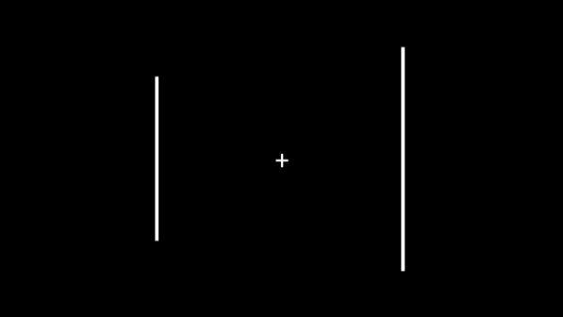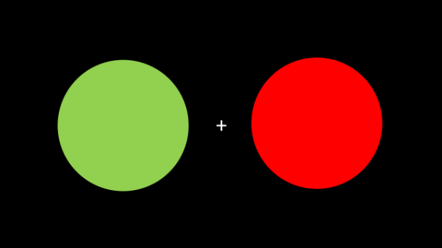
Participants respond by pressing one of two keys representing each choice (“A” and “L”).
Types of stimuli include lines and shapes. Choices include length, width, and colour. Each block consists of the same type and choice throughout that block. Each block consists of approximately 40 trials, allowing the participants to take a break between trials.

Letter/Number Series (6 minutes)
7 items present a series of numbers,/Letters and subjects identify the response option that continues the sequence. The number of is used as the dependent variable. For example:
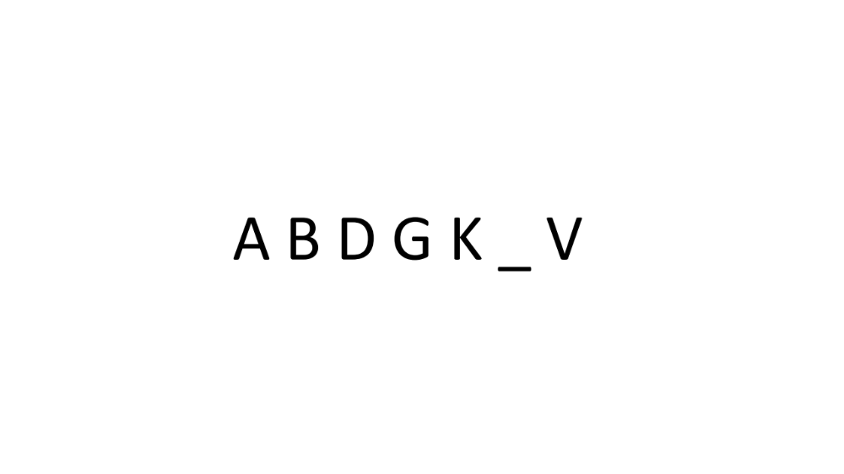

Synonyms (4 minutes)
In an 18-item multiple choice style test, participants read a word and then select and appropriate synonym from a list of 5 options which include distractors, antonyms and randomly selected words. Participants are given 4 minutes to complete as many as possible

Counter Task (7 minutes)
Participants are presented with a series of inter-mixed large and small squares. They must simultaneously keep counts of the small and large circles. After a presentation sequence of around 25 seconds participants report the number of small and large squares they believe occurred in the sequence.

Inductive Reasoning (4 minutes)
In an 18-item multiple choice style test, participants read a logical statement and then select from a list of 5 possibilities which statement can be inferred from the statement without any additional information. Participants are given 4 minutes to complete as many as possible.

Relational monitoring
The Relation Monitoring Task is a measure of relational binding. A continuous sequence of symbol patterns are presented. Each trial displays a 3 x 3 array of strings (letters, numbers, or pictures of common objects). Each array has only one type of stimuli, as demonstrated below.
684 | 886 | 748 |  | LND | HDL | KKD
487 | 136 | 835 |  | CVS | ZZD | NDD
903 | 216 | 399 |  | HVD | KSL | LCD
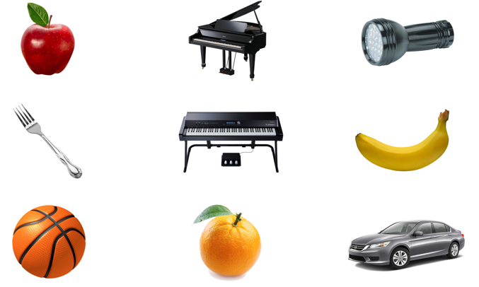
The participants' task is to monitor the array and respond (press spacebar) if they notice a predefined pattern within a single row or column. For instance, in the condition same, the participants are asked to detect whether three strings ending with the same letter/digit are located within a single row or column. In the condition ascending, the task is to look for three strings within a row or column ending in digits that consecutively ascend (e.g., 3-4-5). The rules all relate the strings in some way (same, different, ascending).
In the figural version, the only rule is to look for a categorical match amongst the objects, whereby all objects within an entire row or column belong to the same category. The categories of objects in the figural version are listed in the Appendix A.
If the array matches the pattern, the participant are instructed to respond to these trials in order to be scored as correct. Participants are instructed to only respond to trials that match the rule, so responses given to no-relation trials are recorded as false alarm errors. Each trial lasts between 3-5.5 seconds, though responding to a trial ends the current trial immediately.
Each block constitutes a single match rule using a single stimulus type. Brief instructions explain the type of stimulus and match rule before each block. Each block consists of approximately 40 trials, of which half conform to the rule. Each block is preceded by 5 practice trials demonstrating the rule. The blocks are presented in random order.

Task switching
Task switching requires processes that are not necessary when simply repeating the same task and generally incurs costs in the form of increased response latency and errors. Tasks switching tasks will require participants to shift their response/stimuli pairings, essentially having people doing two tasks in rapid alternation. For example, participants need to respond to number and letter combinations. E.g. responding whether a number is odd vs even on some trials vs saying if it is higher or lower than 7 on alternate trials

Change detection
Change Detection Tasks are measures of attention and visuospatial memory. Participants are presented with an array of stimuli (dots, crosses, or simple objects; left). After 2-7 seconds, the array disappears. After a blank inter-stimulus interval of 2-5 seconds, the array returns, with (right) or without changes. The participant’s task is to decide whether the current array is the same or different from the previous array.
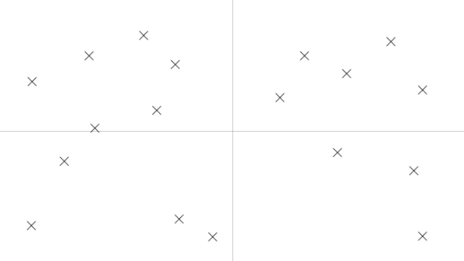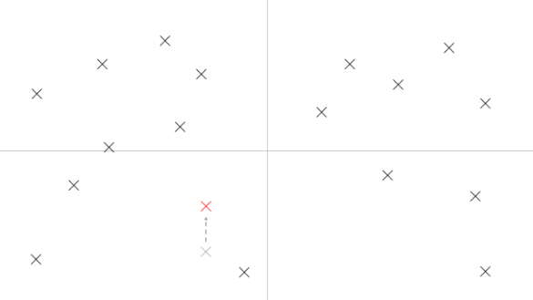
Participants respond by pressing the key corresponding to their choice (“A” or “L”).
The number of stimuli and the nature of their grouping (number of clusters and number of stimuli per cluster) is randomly determined for each trial. In some trials, the instructions are to only focus on changes occurring in certain areas of the screen (e.g., “ignore any changes that occur on the right side of the screen”).
In some the trials, the simple stimuli (dots/crosses) are replaced with complex stimuli (e.g., shells, fish, or crabs) on a contextual background (e.g., water). In some of these trials, the instructions are to only focus on changes occurring to certain objects (e.g., just the shells) and ignore other objects (e.g., fish).
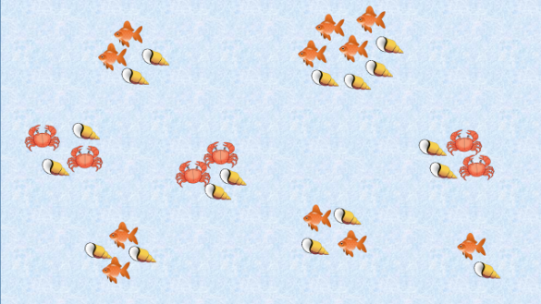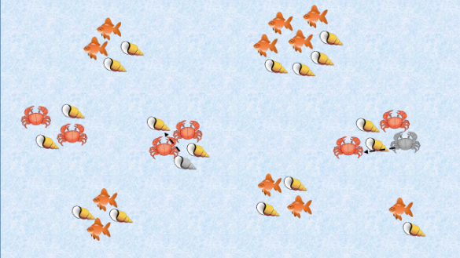

Latin Square
The Latin Square Task is a measure of working memory and abstract reasoning. Participants are presented with incomplete 4 x 4 Latin squares with the task to find which shape (circle, triangle, square, or cross) should fit the marked (?) target cell.
Participants respond by clicking on one of the response options below the array.

Spatial Relation Task
The Spatial-Relation Task is a measure of relational reasoning. Participants are instructed to read a set of premises that relate a set of objects (labelled as ‘A’ through ‘E’) by spatial locations. The task is to deduce the spatial relation between two target objects given the premises.
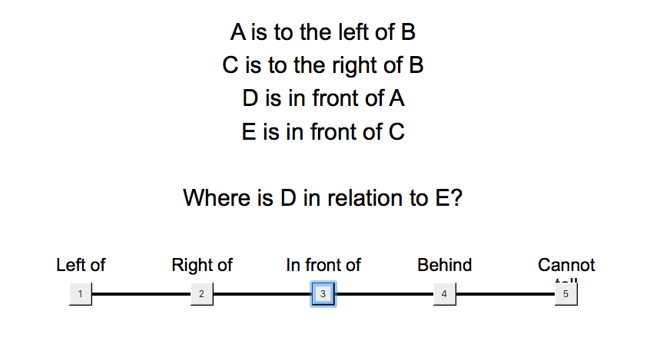

Stroop
The Stroop Task is a measure of inhibition and attentional control. Participants are presented with words sequentially and instructed to respond with the colour the word is printed in. The colour responses correspond to letters on the key (e.g., RED = ‘Z’). The words themselves are names of colours: green, blue, red, orange.


Anti Sacade
The Anti-saccade Task is a measure of inhibition and attentional control that can be measured directly with eye tracking or indirectly with keyboard presses. Participants are instructed to fixate on a stimulus (a circle) in the centre of the screen. After a varying period of time, the stimulus moves to the left or right side of the screen. In the control trials, the participants must either not move their gaze (i.e., remain fixated on the centre) or follow the stimulus. In the experimental trials, the participant must move their gaze to the opposite side of the screen from the stimulus. In the behavioural version of the task, participants instead respond with keys corresponding to left or right (e.g., ‘A’ and ‘L’).
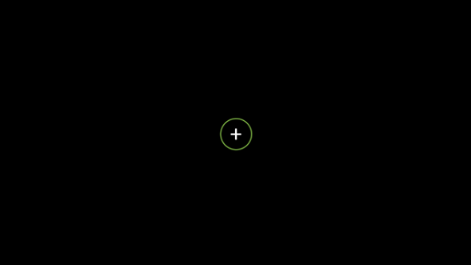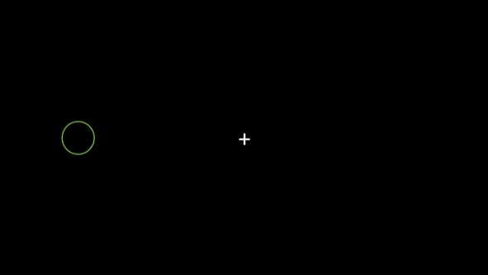

Complex Span
The Complex Span Task is a measure of working memory. Each trial involves the presentation of several (2-7) sequentially presented stimuli (digits; left). After each stimulus, the participant must also verify the truth of a simple arithmetic operation (right). Once all the stimuli have been presented, along with their alternating arithmetic operations, the participant is asked to recall the stimuli in correct serial order, by entering each digit with the keyboard
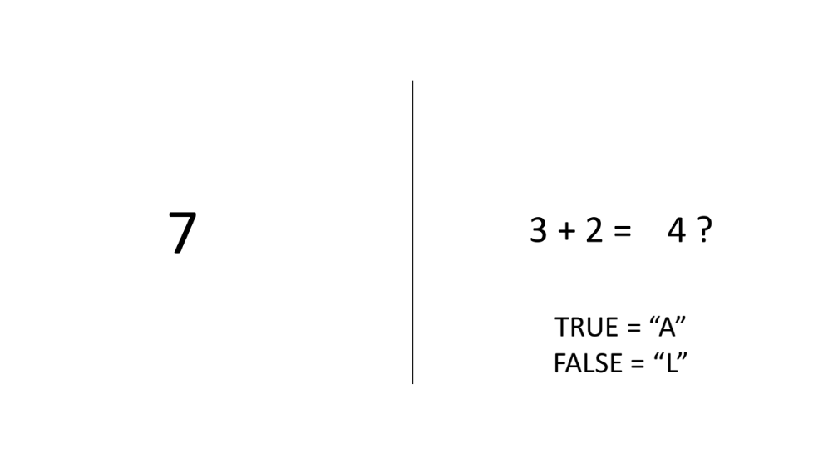

Flanker Task
The flanker task is a set of response inhibition tests used to assess the ability to suppress responses that are inappropriate in a particular context. The target is flanked by non-target stimuli which correspond either to the same directional response as the target (congruent flankers), to the opposite response (incongruent flankers), or to neither (neutralflankers). Participants respond based on the congruence of the target with context, Flanker items call for the opposite response of the target and are represented by different symbols
For example:
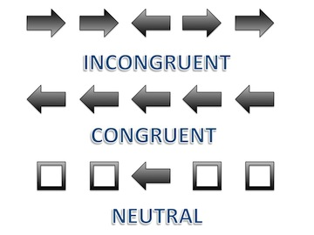

Perceptual Discrimination
Perceptual discrimination tasks require participants to make some king of perceptual decision about a stimulus (e.g. colour, motion, size etc.), usually in a very quick fashion. For example in a motion discrimination task, human subjects decide whether two sequentially presented motion stimuli move in the same or different directions

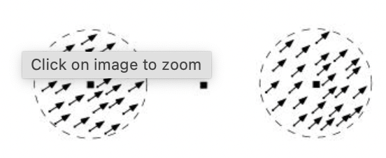

Categorisation
The general categorisation paradigm involves a category learning task adapted from Little & McDaniel (2015), where participants learn to categorise 12 stimuli (figure left) into one of two categories. Stimuli are composed of two coloured shapes, one inside of the other. Category membership is determined by the following rule: if the inner and outer shape matches in form/shape or colour they are members of one category (e.g., ‘blickets’) and if they do not match in either form or colour, they are the other category (e.g., ‘daxes). Participants can categorise the stimuli either by learning the rule or alternatively, given the limited number of stimuli, simply memorising the category to which a stimuli belongs based on its perceptual features. The paradigm is run in two phases, a training phase where participants categorise each of the 12 items multiple times, are prompted to provide metacognitive self- evaluations, and receive feedback as well as a subsequent test phase where participants are tested on i) the same items they saw previously, ii) unambiguous (previously unseen) transfer items that would be classified as one category using the rule and the same category using perceptual features, and iii) ambiguous (previously unseen) transfer items that would be classified as one category using the rule and the other category if using perceptual features (figure below).

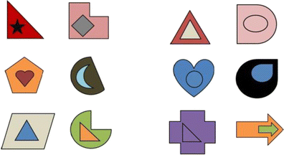

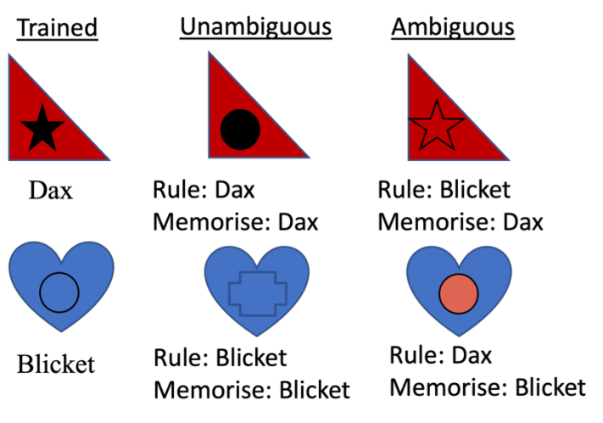

Multiplication Test
Participants will be presented with a series of multiplication questions consisting of one number multiplied by another number (e.g. 27 x 83). Participants will then be shown an answer that is correct and one that is incorrect yet plausible and prompted to choose the correct answer.

Rating task
In this task participants rate either/both the (1) age and (2) pleasantness of: faces, houses, and paintings. Faces have a neutral facial expression. Faces, houses and paintings were gathered from the Internet and online psych-psychics stimulus databases. They were chosen to cover a large variety of styles, such that different aesthetic tastes could be expressed, for example in terms of modern versus older periods as far back as the Middle Ages.

Example trial:

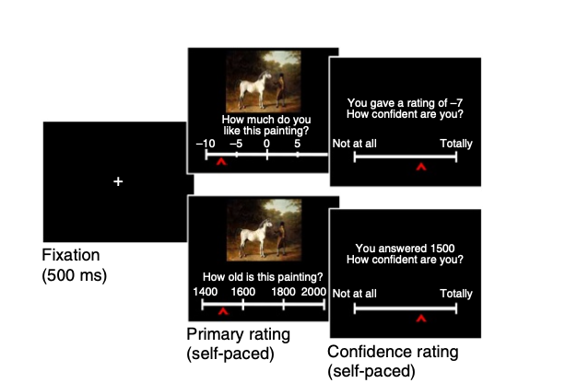

Contingency Learning Task
In this task, participants are told to learn the contingency between a cue and an outcome. Their goal is to determine if there is a causal relationship between the two events, that is, if the cue causes the outcome to occur. On each trial of the training phase, participants are shown whether the cue is present or absent, and asked to make a prediction about the target outcome by clicking on a horizontal slider. They are then provided feedback about whether the target outcome occurred or did not occur. At the end of the training phase, participants are asked to make a judgement about the causal relationship between the cue and the outcome.

For example, participants are told they are a scientist and need to work out if a new drug is effective.

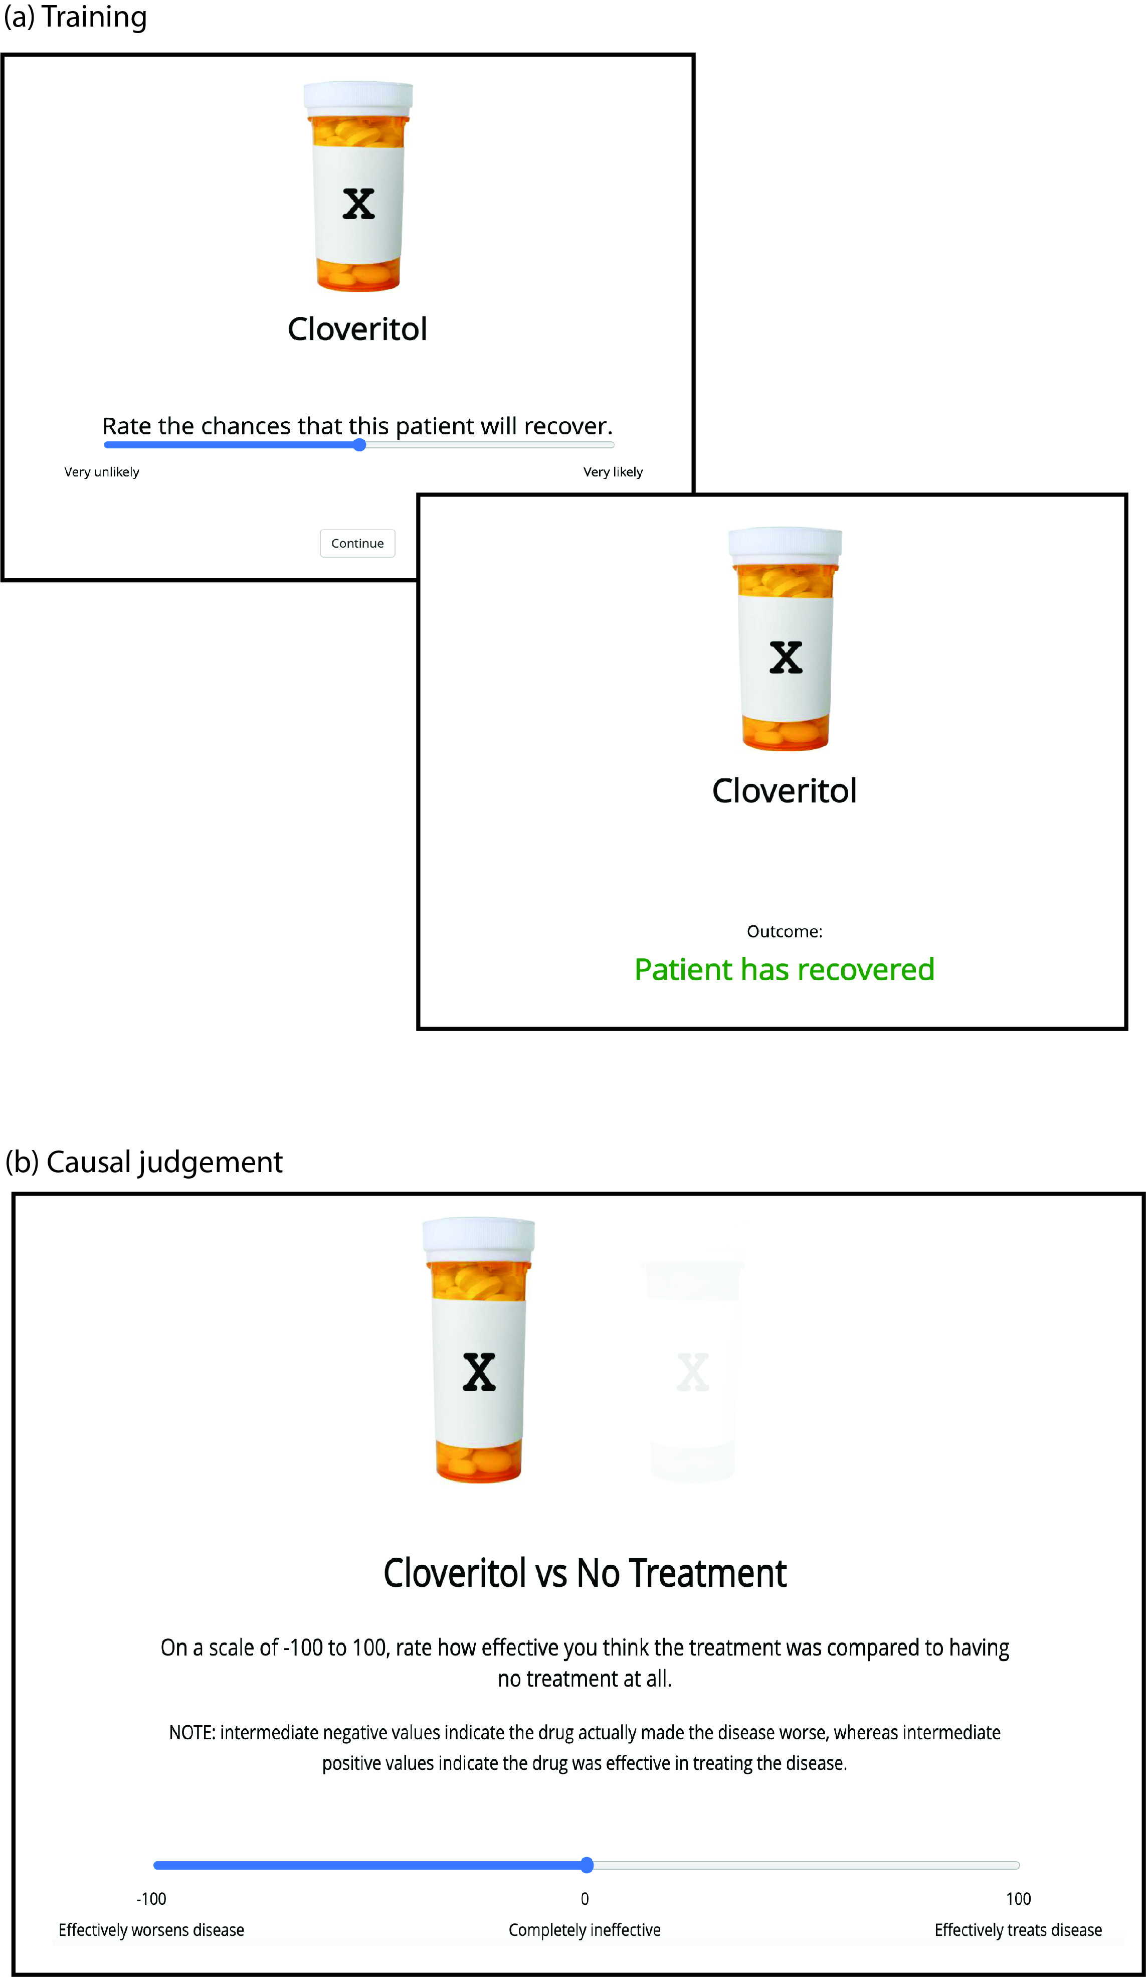

Ultimatum Task
In the task, one player (the proposer) is given a sum of money and must offer a portion of it to a second player (the responder). The responder can either accept or reject the offer. If the responder accepts, both players receive the proposed amounts. If the responder rejects, neither player receives anything. Although economic rationality suggests accepting any nonzero offer, people often reject unfair offers, highlighting the role of fairness, emotion, and social judgment in decision-making. The actual payment each participant receives in the same (as per the approved ethics protocol)

Dictator Game
In this task, one player (the dictator) is given a sum of money and must decide how much, if any, to give to a second player (the recipient), who has no power to reject the offer. Whatever amount the dictator chooses is final. Unlike the Ultimatum Game, the Dictator Game removes the strategic element, making it a purer measure of generosity and social preferences. Again, the actual payment each participant receives in the same (as per the approved ethics protocol)

Learning and Assessment Task
In this task, participants engage with educational content (e.g. psychology textbook passages) through one of different learning conditions (e.g., textbook-style passages or curated informational content). After the learning phase, all participants complete a standardised assessment that measures comprehension, retention, and application of the material. This design allows for comparisons of learning outcomes across different modes of content engagement

Emotional Labelling Task
Participants view emotionally evocative stimuli (e.g., facial expressions, brief video clips, or hypothetical scenarios) and select the emotion label that best represents their affective response from provided options (e.g., “happy,” “sad,” “angry,” “neutral”). Reaction times, label choices, and confidence ratings are recorded so that we can determine various decision-making metrics associated with affective reactivity. Stimuli are drawn from various standardised sets of stimuli: International Affective Picture System (IAPS; Lang Et al. 2008), Geneva Affective Picture Database (GAPED; Dan-Glauser et al., 2011), Open Affective Standardized Image Set (OASIS, Kurdi et al. 2017), Nencki Affective Picture System (NAPS Marchewka et al., 2014)

Analogies
Participants complete an online word-analogy task where item lists cue words in a fixed format—e.g., “a _ _ _ _ _, riddle, guess, think”—where one word is partially masked by underscores. Working left-to-right, participants type the hidden “correct response” that meaningfully relates the cues (here, “answer”). Items sample everyday vocabulary (objects, actions, relationships) and vary in difficulty to produce a broad performance range.

